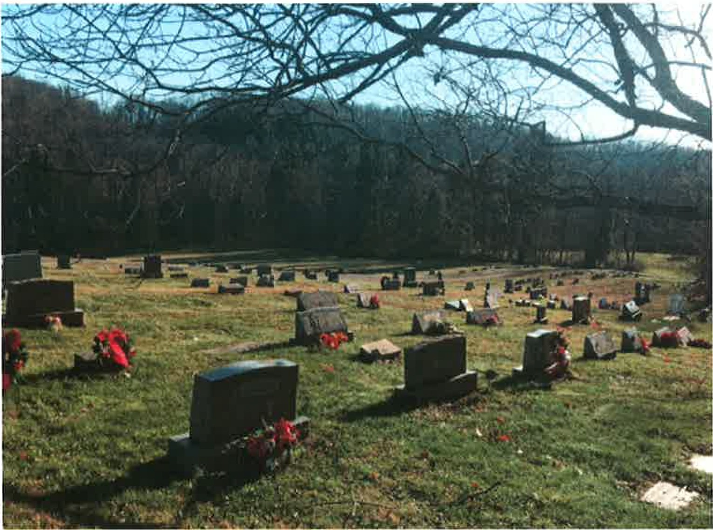

**West Point-Cemetery Association Parker Road, Avella, PA**

The original cemetery was the began with the pioneer Patterson family. The earliest Patterson burial being Margaret Lyle Patterson (1796-1863). Her husband, William Patterson (1796-1879). The earliest grave known is Jennie C. White, the daughter of David and Jane Campbell White (-1860). In 1917, the cemetery grounds were acquired from the Patterson Family and the West Point Cemetery Association was formed. Louella Sutherland was the original record keeper and for many years did this task for the community.

2017 will be the hundredth anniversary since the founding of the cemetery association. The well cared for grounds of the cemetery and headstones have been well kept by generations of association members and staff.

Contact information for the cemetery is:

Secretary-Treasurer: Rosemary Kirschner, 724-587-3153. Sales: Linda Gagliani, 724-587-5616, call evenings.

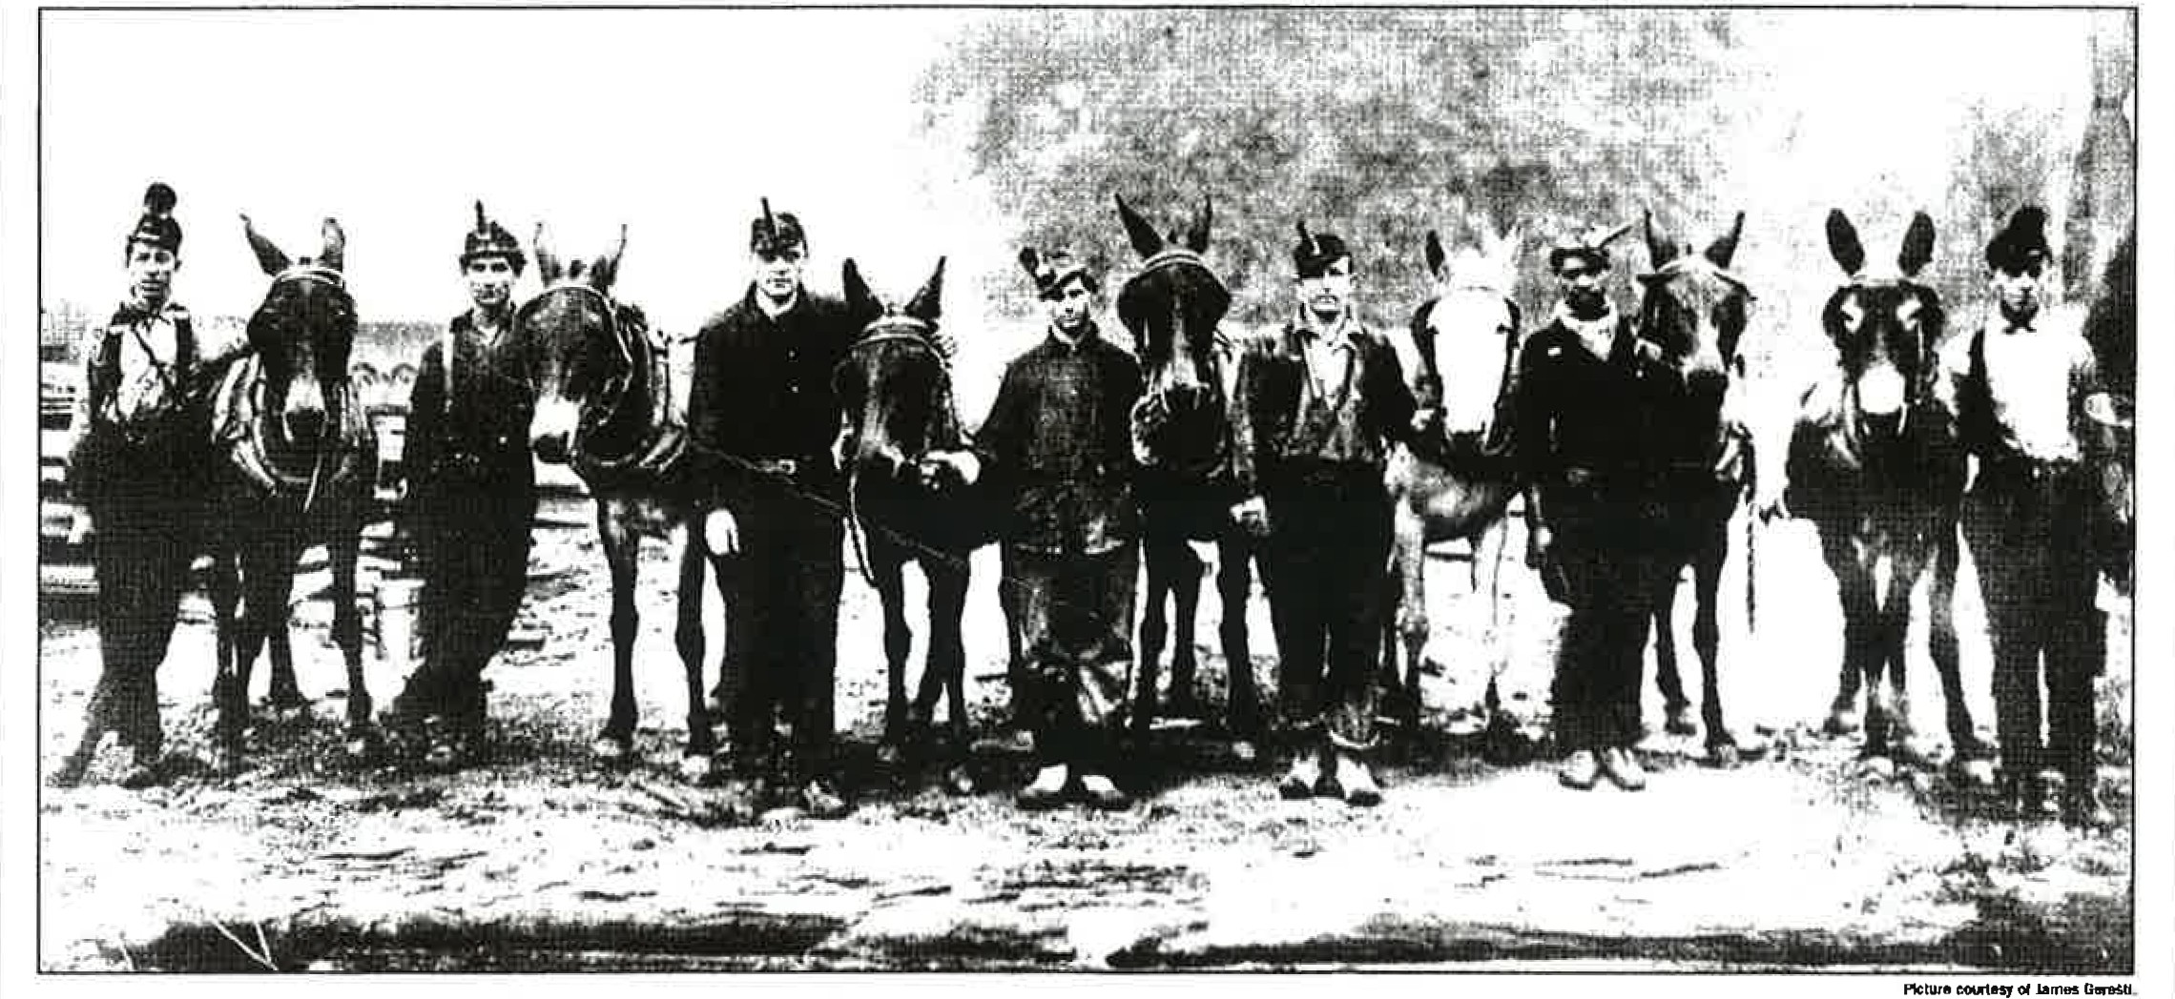

**MINERS IN 1916** at Donohue, near Avella. From left are Louie Ertle, Bob Wood, Victor Bailey, Jim Salvatori, Sam Geresti, Hariy Oliver and Tony Vidma r.

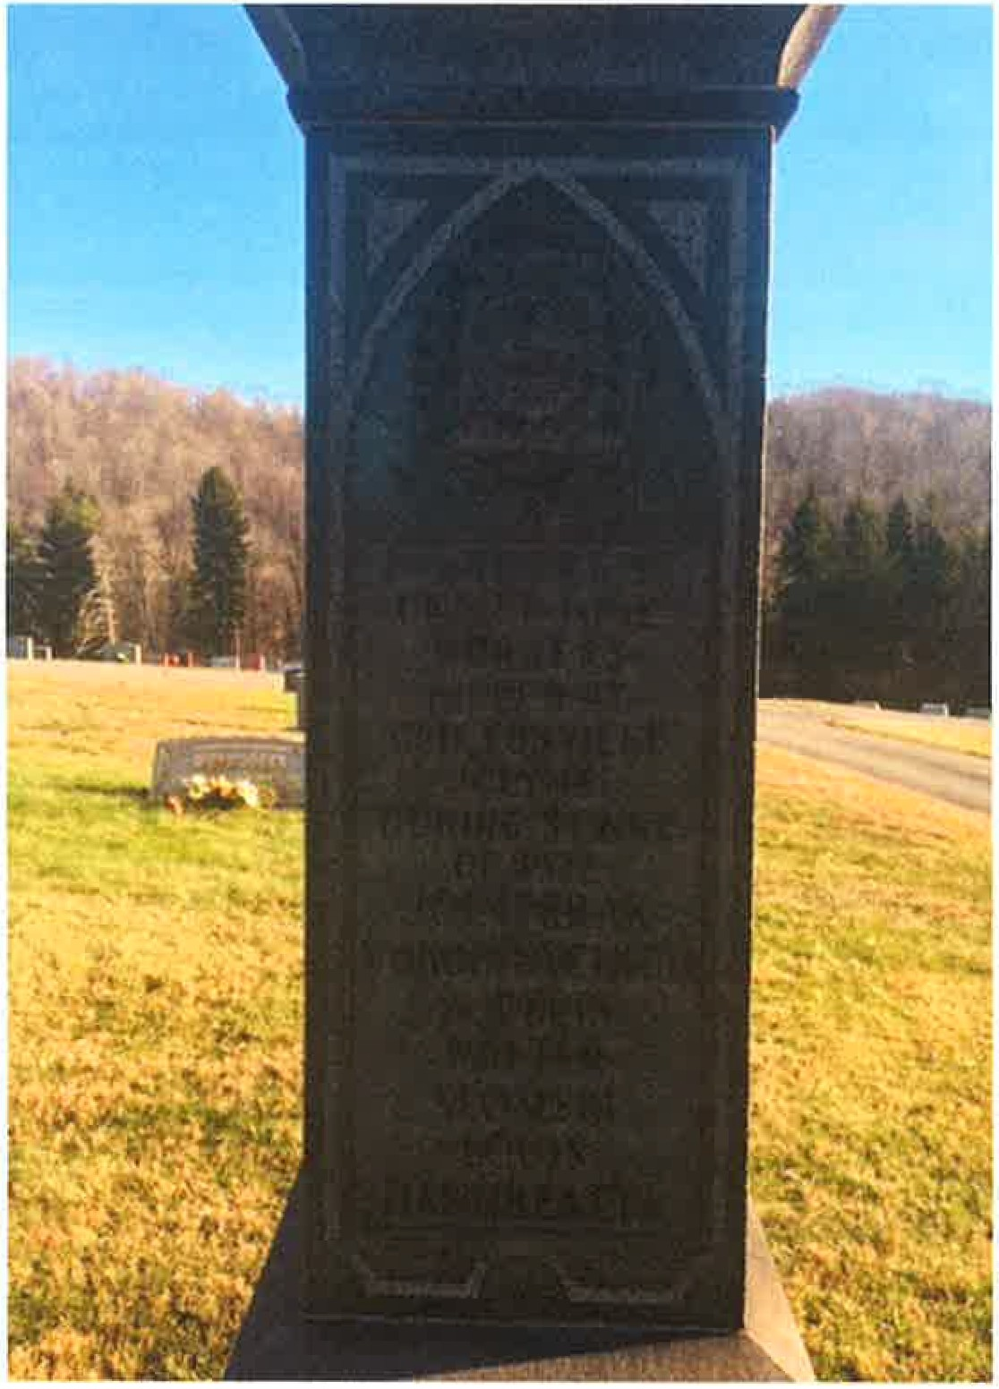In Memory of United Mine Workers killed at Cliftonville July 18 during the strike of 1922.

Joe Perak Yokob Uvchich

A. Perri Walter Slomski

Louis Dandreatta

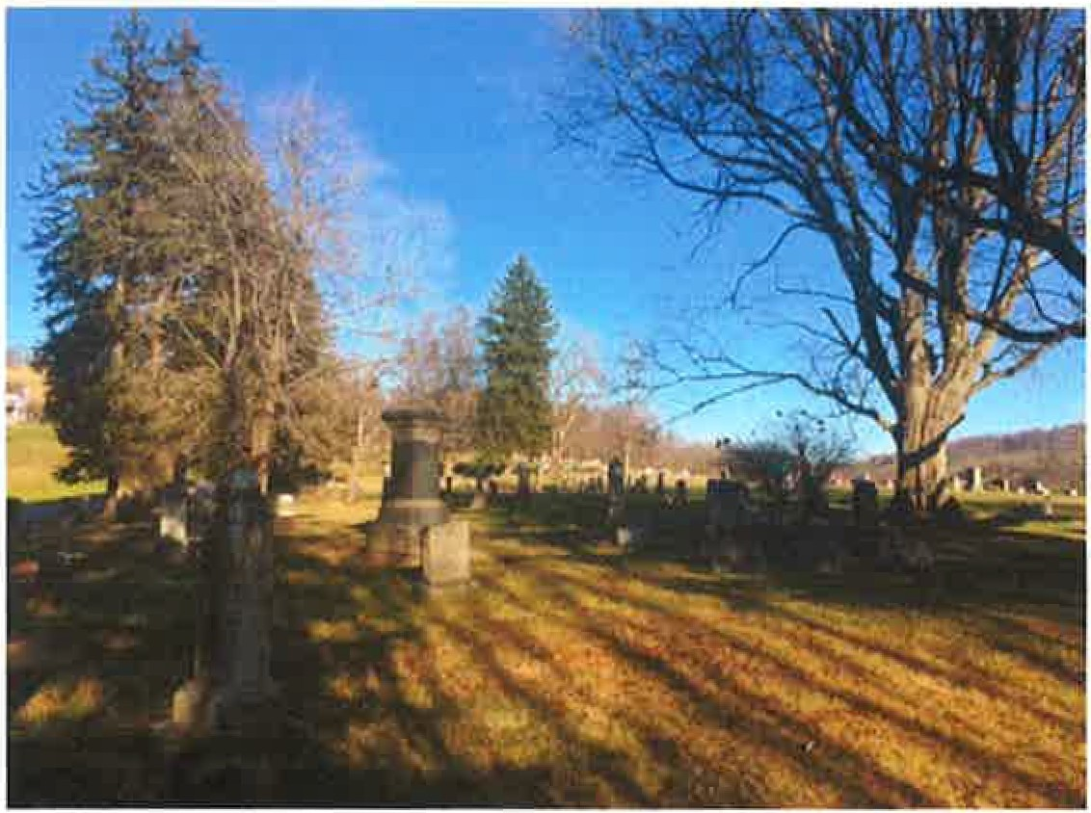 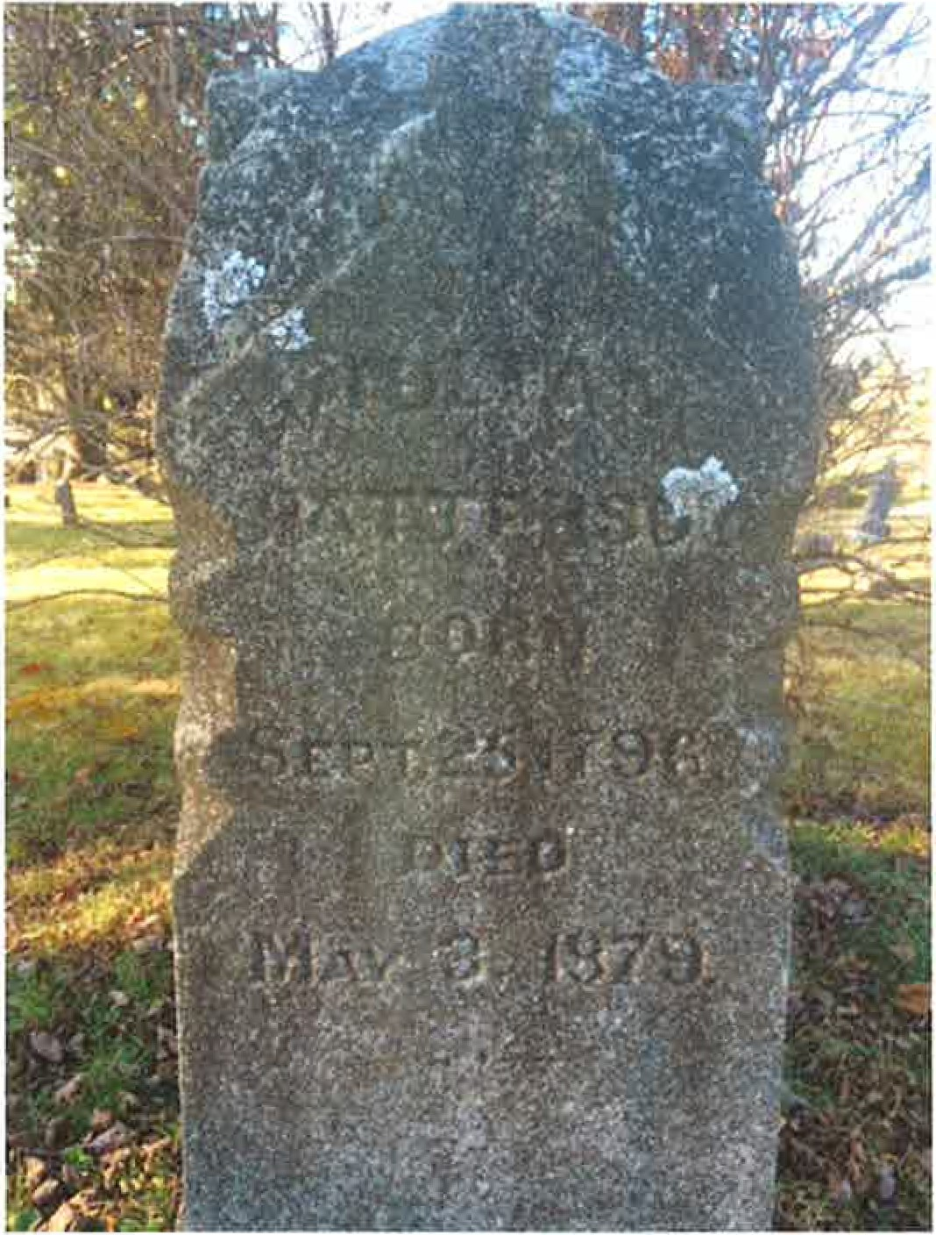

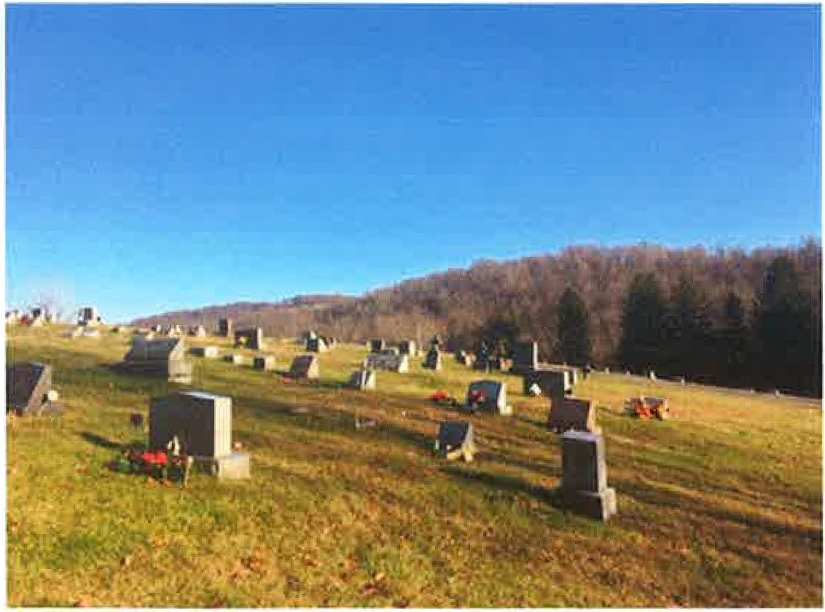William Patterson 1796-1879

Member of a pioneer family of Cross Creek Country

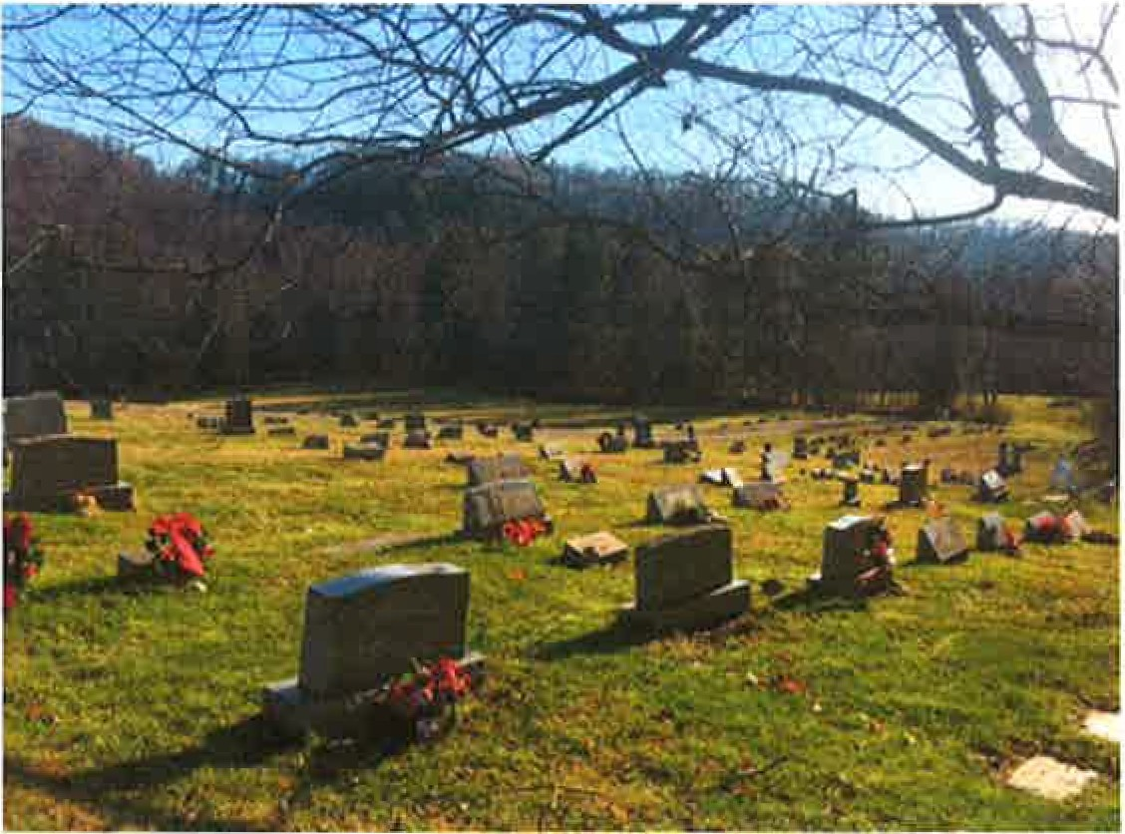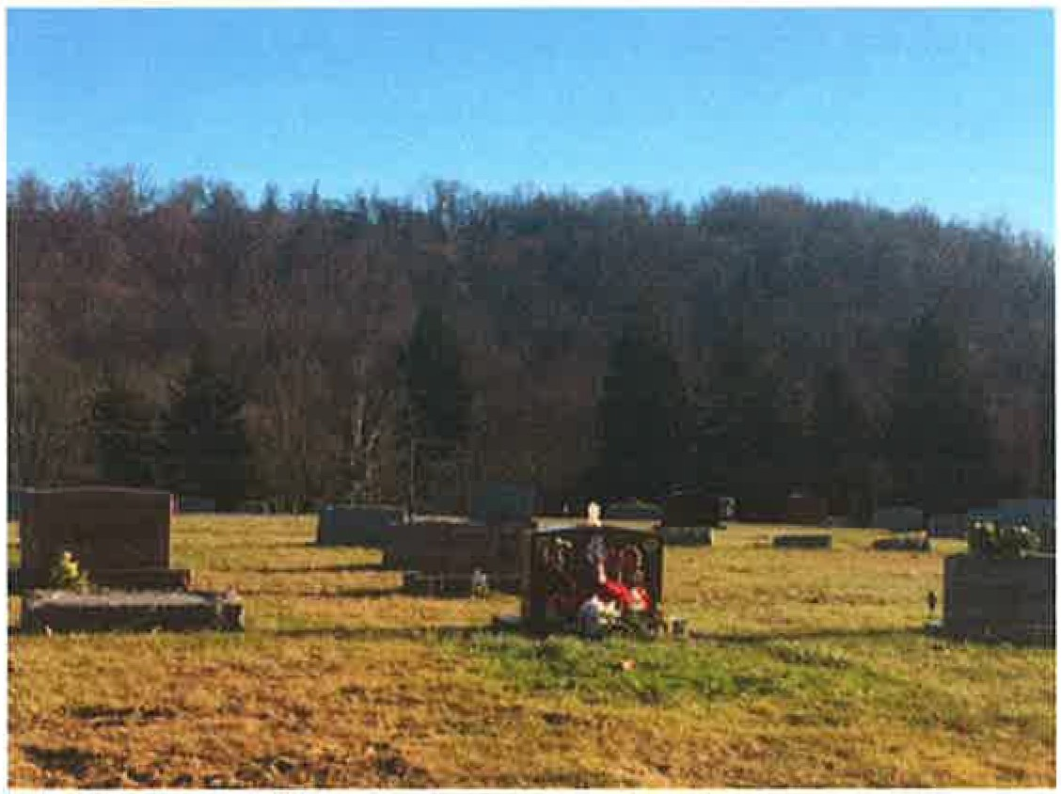

**Views of West Point Cemetery Association**

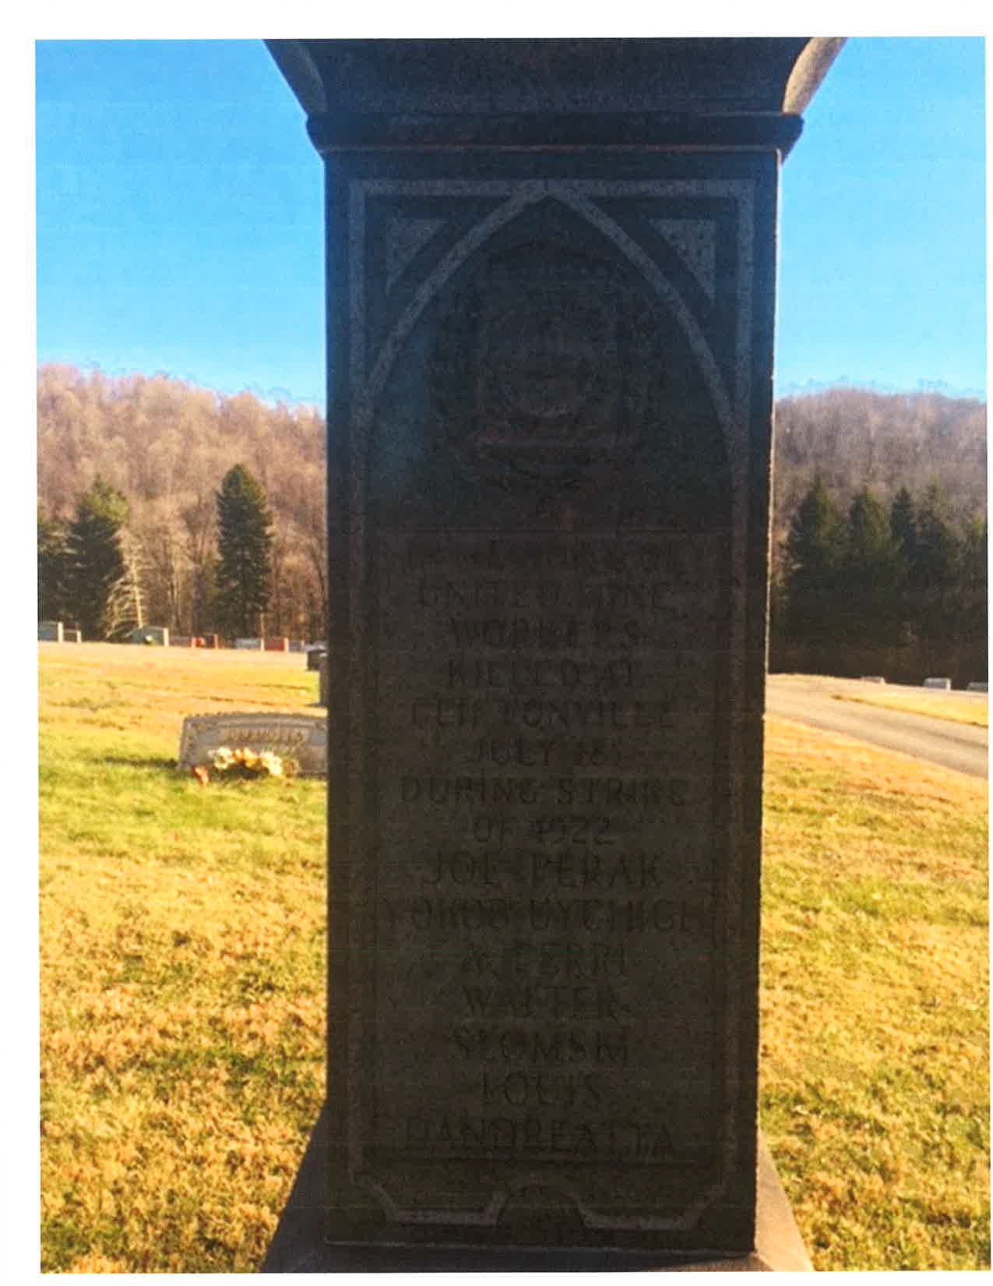

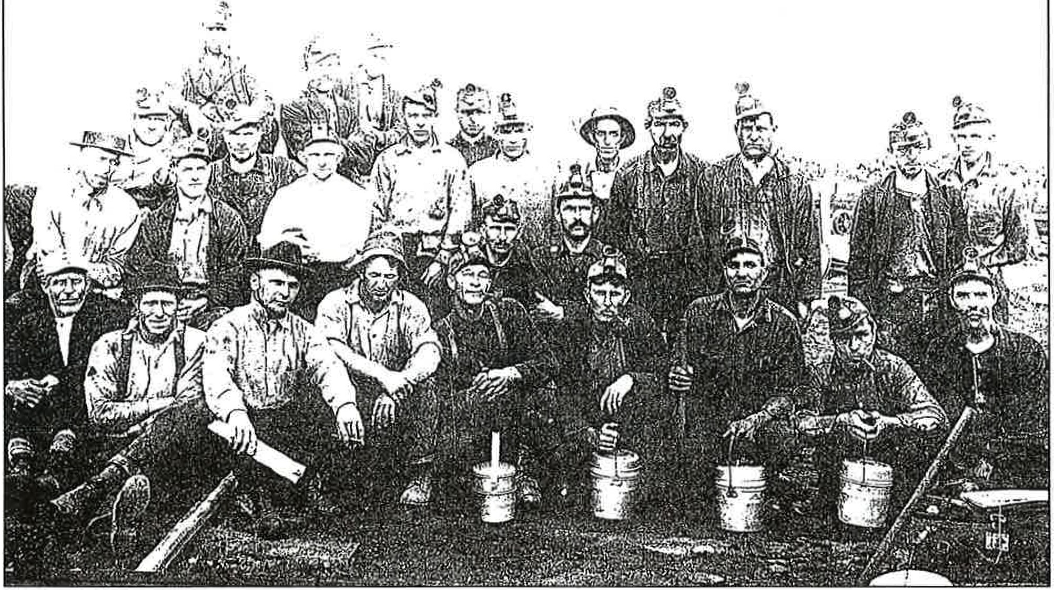

Cliftonville Miners

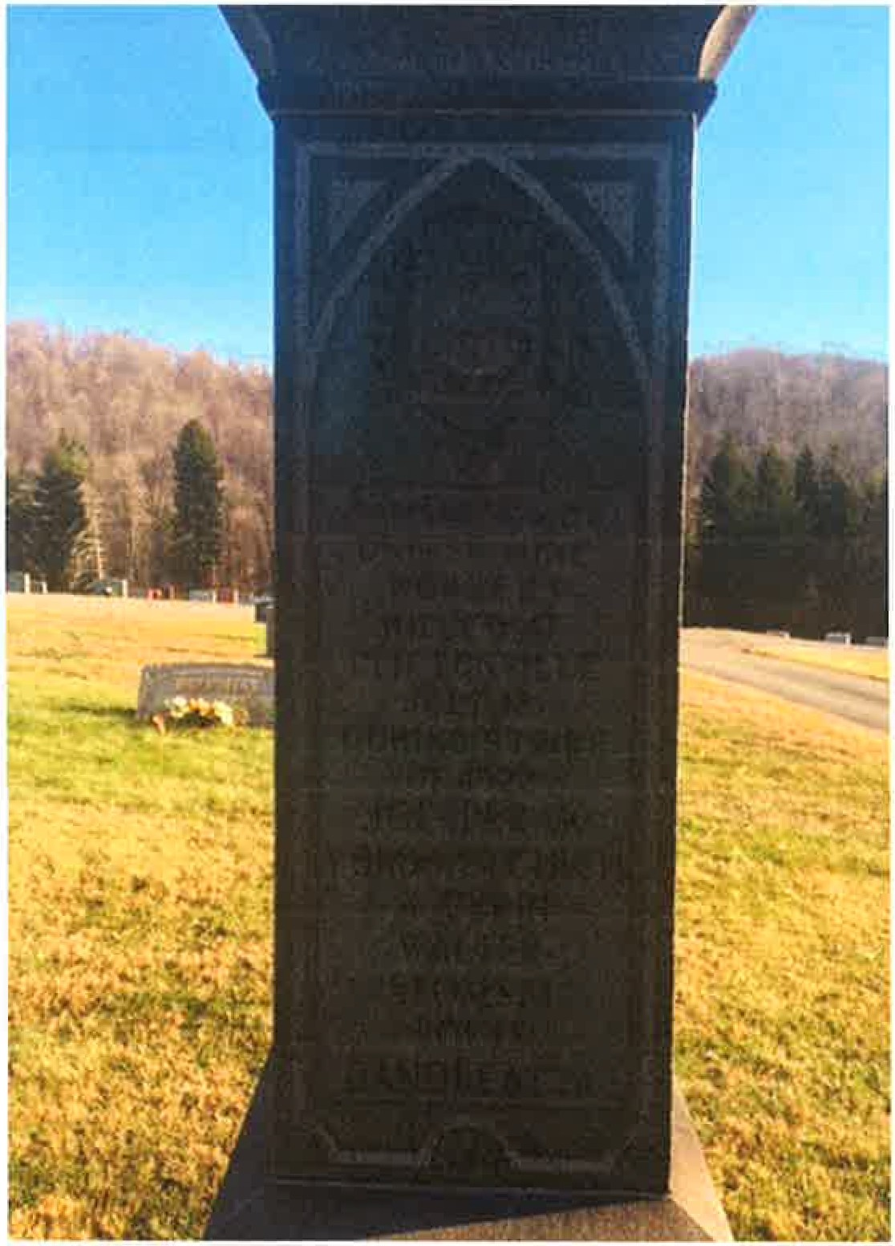In Memory of United Mine Workers killed at Cliftonville July 18 during the strike of 1922.

Joe Perak Yokos Uychich *A* Perri

Walter Slomaski Louis Dandreatta

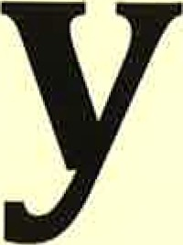**est Point 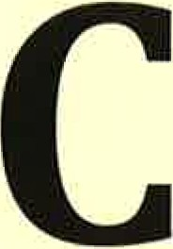emeter**

**Association**

Sections

## l

1

"<:

·'C

/

<J

\lJ

*\ r.,*

:,:: \<)

·2

/

I

Sec... *r=* .SH. ..*G,.*

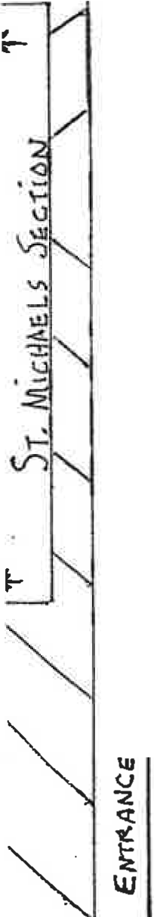

s :::.. G·C.

,.:

U1

:.:

<

l:C:i

B L tlcK16 I' 'Dli:1 11

'1.1

'::>

·

*r:::i*

/

_"I '

\'A

SH.. .B s c.. C

-"">'

('.]

.0...

I'-

°.).,,!

..:

-l

**,q**

SEC.. C.• l .5£: c.. D

'.BL11.:.K ·fo? .DR°l111!

/

· / / *,/*

*FoitM &.* iT o I' , *,/*

|  |  |  |
| --- | --- | --- |
| ..c..A |  | SEc..H I |

/

I ec..1J PA-rri:RsorJ M iL

/

/

,,..,/

,,/

/

llJ

/ *PuBLic.*

Sc.Hoo L ,,

... /

/""'

"'

**<I!**

t-

/

,,/ .,

*-* PAAl<r:.R R'D.

**W**. **est Point Cemetery A**'

ul *"·..:*

ssociation

,,/ /

P R E.k.. Rv ..............

,,,.,.

*L_*

vise 201_6.

-

. *'r ,€Jc- -*

**T**

I *1Dtf: :i:J"' [ :l c,,t" jW*

.. **T** *TiDrJ* ***T***

I **/ d ..,.** , . . ***.;z ..;11*** *"" .':"'* -

I *l t A*r ,*tt' >' r*

.

*t* ·,

*.1I,1•f ;f*•*y r.* I

·0" *, '*I*'i··.:":-'i1*I *(. L ,:. ,:, i* I :Ju,;.- =- Y *l,4Ut,v,.,ji'*

I t'hTI

--

.1' *I I'i _* , •;gt. *t f >'.J i) !*

' ' :>-, //· **- k**

I .

*,4',111-r l.vv* **: fi'f_,lt 2 *r;,, 7***

*C i:>«. (i j) J>*

I 1.,..;

I'..

f *Ke-: •*

"I

*l<•· M IJ/i.1•1<?1( ]>, £,lf z_p*

*c*

I I.

*.Y. t; .:,,J* \ -" *lf!.., ,J!,k y "* . *Y r • Avs K ·<f*

l *;r,*,*,*;*.*,•r *;r*·I

.V I..

::::;

J.

'°!

***1 .--***

***i-.-.w.,:i***

*8 A iJ J>* I& -·

*f{c,,,e J)*

***,1: .,·*** ;

*5* • *'ij, ,f:,*

J( ,!, Jt. l

- ·--

v .., ,,-...-- *Y j» ,,;J •I*

*·,/11(.,*

*_ k' ,<)µ°v* r

::::;

:E:

.,,,,""/f

*(?,t, .1,iP*

... *Af'f'f.gll', l .-1fi'U .&v*

I i

""

• */J#.</,f<_C,* -

*t'f V i .!> v" V*

{.I (

>

RoY ..,_ ***J () J&A. °:***

*Af'PilidY* ,wl'lt,v • *8.-#Cc.· f3 .0rt •* •

- ***C, 1,..,, _...;*** •.

lle.c-a *t,,! fl*

*/<iU .tr .J*

*,:.,*

0

I

*,..;,:..;,.,.o*

*,;1 81 1 1!,i>j")'#<" t7, .1, R7J .41',' L• S 1*

·<

*.J)JI"V'pt.* p

. *!1PF'tW{* Tf :

*,rh <tU l :;;u*.,.. . *e*a1i

*e:·r...,v,;J i*

***K****o****.****_.****c****-i****>****.. ., .,._****.****p*

Gsll,.6u

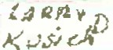'"'#'!,'= · 1:)

*#e.vR; .;,<1,*

*l} // ,1'{ .D*

I

*I*

,L *.v ;J. /ll* ·=

;-I

* - AUD"',i

/_,..v iv f - --,iio !

.!.

).J...

I

**f f ,'t'Yh t;..J',,/.:, J *A JJ-ltt°-p 'ISI{***

' I,*t><.o*-1*/lC*;·*A*"*!* " I I

·-·

,,_ · - , _

- e<;'!! "'--

*j·/·* p

. *Re, ,;4 a,.* -

Ln 7*· ,,_;*e*: e XiI*

m

' ,.P

..,.......

*w mR*

;, *l_:'4-,f..(*

r, '

'

*/* '

*Cl .u ,1',,l<:>*

I M,. . *• L*

***'f!:'."1,***

,,*(* ,,*<>,Stl* ,!";

***lit*** :ft •*It*

*J}p.u M f*I*w,i .*,*.,* • 1

*f'&w*

!oQ:,

I f<*,,*v*.*t*.*"*,*"*,-*..*<v*,,

*.wi, e, t..*

*7 ·(,;J.* I

I

I

*!*

*/>¢" ;JcJ.,.;*

.

I *II 1f .LJ,x,{, ,All).Jl},I*

*Cl1J)(!.*

* 1. sI*-fi,.,.. ,,,isI'*

*r*

*t, .Vt"'t'Z*

I

'Q"'

,12- _ _·

(;.

:)>-

***-- -+***

*S'l!* (..

!' *!)* -

u •.S"· or

*W;11° •*

***---.J.._-***

*(*

-"' *,,.,.DA* J;)

***.....,.***s***-.;***I***.*** *fibca;****.****,****.****<****..P****&****.:.;****ts****..****;****i*** '

I. - -

.

.

I

<'I\-

***v s***1>***-.tl..***

I

*I*

.. I

"

t

I

&/t£fJUf"' *!3H'f.lJW,."'*

*tj.*

*I*

1 I I '

i

*r J{o;t;'.'it!<)* I*f'Jl,,,.pj:;.,,_}*

".=..' *I*

I *.Jf!.',::_J:.:?•.J* I *[llo>tP.!-•.,J* '

'1;

8 t1 *'l'.,,,,.1* l.;q iJ..< *r e,.)*

r

*R X 7'D .J 1:?.r'*

*r' i> ,J*

.

*(,MU,,.,*

I

*1,,,1:.,* Res

I

_I

l *(}>,;*

l I'"*c*'*;-1.;!.;:<rf;Ll,,,..l,,,* ;

i · 7· /i *P*

* + - 0I

I

I

*p*

*ft .)* - *. f. .·*

*:Y;'"*

r-. *I* l ,4tJ/J II

*iJ l* ***6*** *.t,e:/' J.;/{*/5

I

l'f>

OIi

* + )l

,•

•

1 I *-·-t ·*

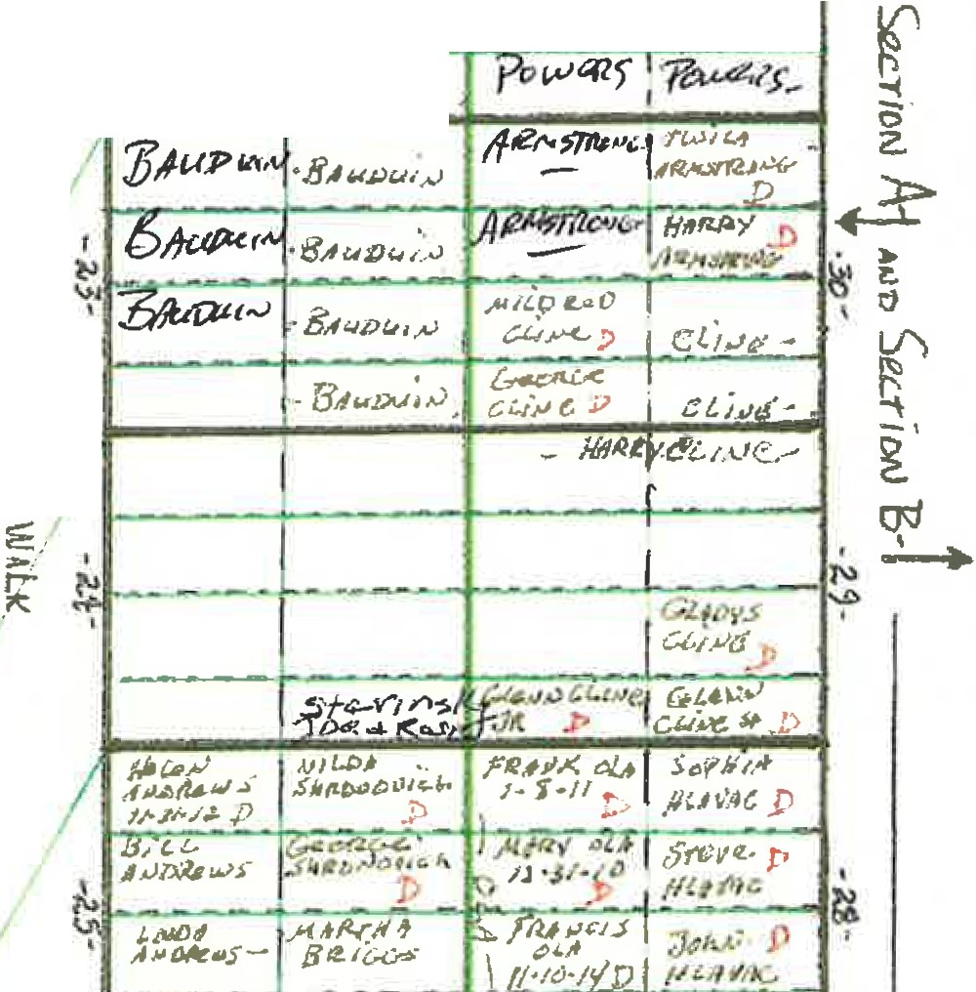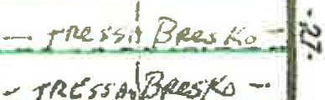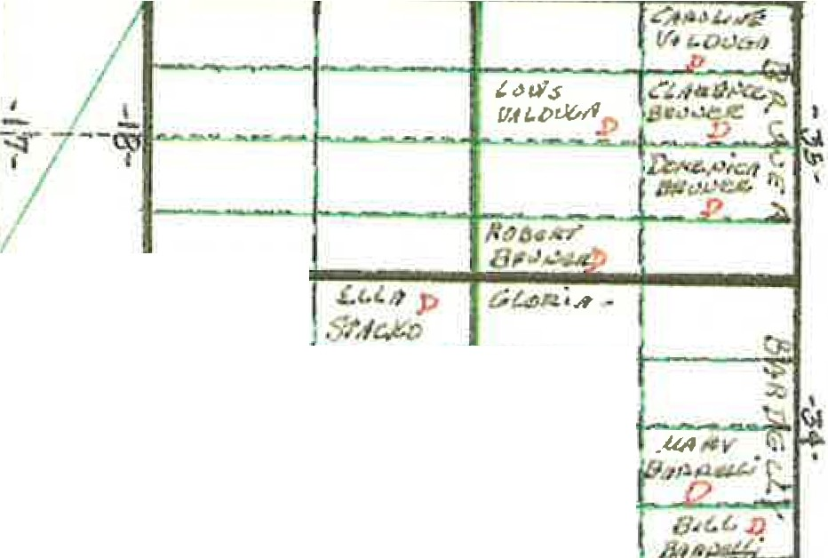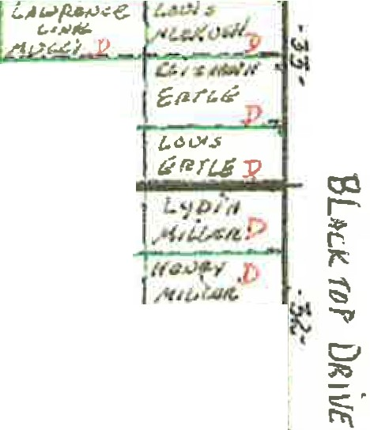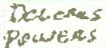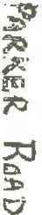

-., /2.Cl

•

I  *t; L;U, ..., (Zen l;:,*

5;1}\.iiA.t..". - - - - - - - - - - -:.**9**

*:t* -

~~--~~

BU\ Tot' **Q ivi.** .,.. ST. ,NllU' f'.E.L.> +-- *JfC* Q{31J *Fi*

*) t>* .. *,J '.11Gicl/*

"1<! i -

*k}I*; *&*·*I*'*I,..*

H Civ,12L.::·)r .

trJ-:..I 1$:_ *t:r,;r ,I* I <;- *1,1 .,.,Z .-:,*

*I "5/IHJ'. $11,d* I *t:. l :1;/*

- '

*Ii* 511..

*t. .",Jo. p*

------ - ---

*j<:.*

*i'* k,._11 i.....l.- (;,d;iJCi.-0 (. I

-

*4}.««r*

*,::J ,.L,i,.* p

l

I

*f<t.l4,1c,K;f*

I 't · *J* J .!.

*j<:.*

*i'* k,._11 i.....l.- (;,d;iJCi.-0 (. I

ic *11*

'

-

f,/f *Cit/ f(<J6,><!=R* '

*4}.««r*

*,::J ,.L,i,.* p

l

{"""'"\ -· - r-

•l-o D

._,

'

I

*J,Jm7*

.s.,/..U

*-Sfll !JC*

l

.... :;:, *.J:( 4_..v ;,'. /!* ,:_

, *tf ll i M* p

l

"r3-) ·

1 *L,,,.Qt(*

*. .J;! AJ,f [J.t) .•V,/ J'J;,J,v* Si.$-',IJ ..4,.,00,. ...1 *>*

*"osi:..-; JJ ..,,,o P 5),',i,f1'UCJ* .....,.,,4.,-,,,c._, o *(' _*

*p* •. **l't**

• *l'c1i 'AJ)/{*r*,"I*

1. e'i *7)111,* 1> *.),,II,>* a

•· *.f;J•U.•I*

0....

r . -

*,5"1* f) *!l { }* _..Yyti4S *""'fen*

... ••'(: , .

. *\"'"'6"' l.,11l* _.,,v.ffll..> - *!)(l* ·1

. ,t.:,:I

i>' *r "( .;* rs:. . ***/t, 1tffdH;,*** .- *r,t,tt: (r-1/1*'•*:*h ***,..,t11..*** *r*

2. I ;:: r--

. ,

I

<.ii

.!. I -·

Ice--::'i::,..**JI)**

I

;:i

'"'

I I fl'

*/j:.Td* • [I'\

T --

*1:/H6'fl -* ,'V!Cv *,tRJIJ 1'1RSd. >JQl. K;lf.J"d* t

I

* + SH

o *I ..1fl""'1t1for'*

*0M-fl1· ::fr,J',.,* p

*r; ,..,* ***1<,a.Sd<l'tft'*** */t1flxf-f,}/lf,*

*(D 6- <l<l<lt<C*l*:*

/,:.o *d ,.lf.11/l&hJq*

,,.,,, ;,

**J;,,,,>**

**"'/V/,t,R,**

**, ,h..."."'**

***er.*** *SJ9fJ,1*,*,*,*;;1c./ /JJJU* F ,. .,...

. -

1-.,3.\ *t,.,.1$(1,#:i '{., """"--;::te* (.:.

*Jll/1$<1,>'IZ*

*Ioa66.li*

r,

v. *:;;:*

*fk,.;,..·,1",.-, 1 .-J, \?l,.ph .1;/ /;.,di.TIP-*

*IJ f',I• r.;· ,:J,..,,,wi.;*

( • I *:...:* I ;U. (.4 ,;Jtyo. ,,,&,"1' ·,

*B•rt'f*

*) >Iii"- 'f.;.•!l 4<,l./*

0 ""·

I

l>

*Lr.x;y* .

-·*.:*-*J*

.. r· e.

g**1--'**.I

' , J.

*.f:/Au/J •* .,;

*tJ :,1,:* . *7,.* I *:]IJAJJ,>*

*iJS/.1.-,.ol., L.crpl*

*( .t.!D il 1,'-'l<* I

*. oJ fj C6L£b* ·.:'d .,_

\\ j )

. r"'r.- r

n *I.ViJLi-.f,:;d* , • *,!·/.! . ;1 '""t"i "t>(,t --;1...-.l.1,A,,J*

t;,-, 6 *;:;;J-wl..1£-li* ,L' *J) :f{'1 r* ! "

*oD*

*[ ,' Mll£4,r "'*

,l' ,:, ,c t! i.U

*;1,.,_; ,,, ..."-*

*(t JLl!fU •f* "jo-.A) - *1 fi f.:.lc p ., J.4 t* .....

-- - I

*I* I ..... *'f!ll/t,cf 1),st.. v;,,R.*

- - .,,-- -*p*.--

l *( · ..,'t.!.s;.*

l =

*:*

*i·*-*-*- *M.1t'.i:-* - lf'I

sD- l N

-

(!) ,:...--.. *#W*

"j

!> *:;. ..,,w,;, 5 M f ( ..J-Sf,_ f , n, CJ ....,. t' i:w1* I

p

G' i

*I*

\ ., *J.. ,...,* -

·"

l - j;.:=, -,

' *!lt:eiltll* I) ·

,.

I • t

*,t1tf,VGY* 1 ::c;;

:;.,,,

*rt* 't:.

a.'

;s;

I *Pa,«1,;"* I

*(_pt::* '"-

*J.t( ·*

*.»«t Jl'* ,

;:-. 0-:,.....,,,...

*6,J,,J:f! J; e*

*'Y !i>*

L/\

'-<

"'

1.

'\,J ,,,. *.1- .>.-;;* I*t t.;. ;.J* Q

*j,,,,f,.,SJ<, :,.,,-,p y*

*,lhJ>' y/1.S* ....

1 ,-, *-:fl,*' , ,.,

>

. 0

I

tl'!1CI *r.iJCL.t,".,fl. -r*

***':,FJ*** i.; _ *.P*

*i,,.,,1,.io/l _,<,<,1fll'(; y*

*0:!'l'-'1 At'L*

*/{,I t..{. JUQ Ii*

/ > *::*

*./f#e.*

*:},JI 1-1*

**rFi** *G.:-u., ,.,., f..:rt c..,..:., ;\,>C, f,. fe 0* /4.,,;d

n · "

C

*·.J*

*.,.,,..,.,.,,.,<:,,«J<* ' *0 ;J, II X. · y,iJ)l*

0 , l ,,.,c ..- y :- ,,_ ; ,t\..'<J *£A,.; LJ l* "I'd *l.168>* 0 *LoJJM*

' . I*l'-,* - I

;_

' *,.:,.,. ..:,, ·*

C

*(. P-* i) c-•.,:; *A.JOl S l,! .:o .:, ,t't.lH t """*

*!* -n

*1n 1 :.* ·

*/:oRfy.1,M*

1--' •'l'

-·

,.. *t:x· IJ1,'* ,t.-· - !""""'!! N

"!!· ---- ....!-.-

*L..,' ,.,., Ir,)*

re .. *C,(f' c»f*

(.- (..." "' L.\e "9'

C

0

*VM!<::;.;*

.*\* .*l* .*>\ , l"o.*.p1- -

*Cll ll(; 1PIJ 1-·tt -1,,e; l:-1Je£y,J*

*('llfft,(,..J 1/ tJ l, /JiJ(,,: BM IU (Jc,r,,2,1/JZ*

.

{) :I) - - - -

l

*I*

*.,,.,11"'""*

..... *A-",..,* - I ***_f*** *1,H1*

G a.,;,;ic,,....l oa0c,...._.... /;00.Z.....:$ , .1,i 1--•r,(p-_

,*:*.*J*.,.,*d*,,*,*,*-*,*)*.*.*;

, \ )

.f' I \. *3 1' ?"/l,1:,_s4* .c;,,:. *St.l4_ f.,,* ***Jf//A,4/'***

f./. <J /1'1· •·

:I,.:" •/",*.J*

*Ci.,vt >U , T.*

u ...J::i,l"- I *ti(6//***,I;./** *£<i YA,1ca, ,j1J<?:',<}*

I

';\I *,AfG[ t -.., ,-.,;c1o,f. fa"!..,I.* 7 *.:,J,.IJ j*

13'

I

*f.:/J y/1-t J.-i' .'* .:GtHlf.&J- *WJt- A,.,.* I f'

(\

jf *::. f/;UA•-" J{,t_t.1<-J<.*

*,r<C,l* . I *.l' ' (;.(, 'l" "-'"1*

*i)* 0 *J,{ JJ>*

l r'ii,i ..:i ;_. */) f'I O*

I

(\

*c,, ,.* t ,• . *J i:,e* st·JI

13'

I

*f.:/J y/1-t J.-i' .'* .:GtHlf.&J- *WJt- A,.,.* I f'

,- *B t4:.t·*\

I

(\

*P,;U,,."-1<.'*

*i)* ,1 -..'..

--; *£ ;.q,,,.,*

I

.**l**.**'**.**J**.

*C',*

*·:1 ·1.. ,; tY' rz. ·r 11 c:.-* ' *Ct1-,.,11<Tf1 \JJ J...'!)y il41lJJ.y* .

(\

:t> *,1-A ! : f',;,,t-t.....,f.vJ 'G &t.-c>* .. .,. .....

(\

I *f-1;,*

..... ,<, le

*Mff* llll-' *l".11,-Jft,,J(;. ,,..,U'1'1f ..,,· S11,.rN.Ji.,*

ff·9.t,_;;- . r - *L* . - *s;;:* · 1_.l

*J( rtt"* y r' *.J i..0,*

*u ,.# / .Jt ?,,. ,.:..* "r-" ***l't*** *:Joi,,) ""R/l,1fi,1,i*

--......a..

-

*D,{J;l'I'-* ·

i) r, 'ft

:.:,:.l .

*/ V .Jt.[?•( ., ; 1,1,,.*

-*.r,,r--c-* '(, *Pif i" ,.* K

*t. t:J yu 1'11,4:,/Jif .s-11.w"'..i r.•*

It\

*e,.*

,r M *R.* C.:A,(fl' *'(cJSf/•,...1* I *1.1..u,#f!J.*

*::;o r,rJ s., -,,,; £lJ.i6*

/

, *..i,*

'l;J:) /J *L .s: : j3,; 1, , ,-·1e,J(. l<,'-v"f,:.*

*I*

*;.*_*(* .... ""_ "..'.. """!. ..

_ ..

*SROD/9 IIA 1.gw.4 u- ' " 2.* svv,,.,,.. .

..:-+ r,..J -..: ;; i..-...- :i

*:1. 1'*r *"e, l ,4*

,.,,11,, *V ,I J Pt>.,.;,,J,u* ***A-"bM<lJ***

tr:-h· 'I/ *A l.a s . ('* I*13tt /\J k.'.:'..'- J<'i<.)-,. 1* IC. *.$***,f(.1** *0,A v..1.D,;1,.1* • *IIIIOA*

I

· I - - ·- ... ._. ----- - ··"'I::

*I* e *,..,;-;1/l,.,;*r> j) **.0** *Svv,o.:,-4*

R. *1 ?, 11»,,T,i1i1*p, . *w,* . ***4..*** *:;1.; ,Jgf* 6

r:i

***..***"***,,***"***,,***'***.***,***.***.***,***,***\***.***i***,***l***,***>J;***

*C>*-*r., 4J(, il* ***otr.!( 1***

*/('f4.VC..i. l 'o :. ,c* • *.$<).,.. ;P*

*I(*

:5011 0ii

Svv.iV,i

- . *_*,*·J*,*!.*,,*_*y-,.;- ,_ " ,,***<.c.,1( . ·*** *V*

*I(*

*(,..*

*,, ,:*

*{)* . ***iJ(.),:,,i/,vL.***

-

CJ

"*1*"*7* /I *,t*;*J*

*I(*

*(,..*

*,, ,:*

*{)* . ***iJ(.),:,,i/,vL.***

*xv .>w:.*L' *.: ..- .:..1 1- Cqc;c.J,1_4i 1'W'l't-' i, S J,104* SLlV,i;;,,f

I *n rt /t vc,J*

«r,,:.

·"' ..iee, ,..,.,0 .11.. ...J *;1,,rr Ue,jnv(,"='*

*&tfle,,r/ 6ts£ >fj {j*

,,. ***t*** *:* . *fi"/J* >' *r.,*

***,***

*p:,//;,;ki(o*

I . -

.

~~-~~ - *(!,-IS.>.;*

***t!i ,*** a .::: *J* --

*l)i:..J C:.* **n.**

I , *L ; llJ ,11,f.n;..-..1 .-* L.,: *.].,J,,,;* •

l'9,.j (.,.6r;(.it9•.. ***- t,«. ;}:***

_ _.,. "

- - ..

*--::b.,ef".* Z-i2.t-f1.

***u*** ""'

**E -;;,;- *!!Jii;***

--.- · . ........ ..c

,..,;;e

,,,·-

*f'"A,f /:>!..! '* - 0;:-> t.,<;'., **l-**'**J**

1,% *IL ,* VI •

-- --- ·

t

I r--. *r-* .J .....; - '

*µ,1.:,-,,.r*

*.J)*

*lJ;,* <J:,Ov

*t.1U*

*P /1.J)),(*

*oP.w_ved,* """"" 1·

- - - - - ·- - *I*

*fN!DA* ***i7i '***

*G.* -'-"' .:,, *,< , :4 .& ·* ***] j;f/t***

*'=-J.fat* -

*/r/bit .-i) 11*

*I:, ,,JOU.*

*;f ,,·l,..,*,'" f:",tC..,.f"4/ *Dd s.,.J ll* **j ., *..F*** *IS,{ >'* , */:* 4'1· *f'.,;f .J,11<,' !>Ot>r1,11Ul.*

I •: ..q{I!.,,; &

·(', )1

17 *l l* S/V(]!J. '5 l:J

- , o-

,IL

' I

N \

*I*

Ii

*I*

, J ;

*I' .>1"• ,;,c.Jt*

l "'

*,-11<.•t•'*

*\*;fA,'-.,,'*

***;J.,.t.A)***

*Jjt4m' J'*

J....

ft

I *1* :

' r- '

7'.

*.1ti,ti*

**t)/'Jic;;- t. l**

*;J ....,,,*

*;f'T'fl.,>fJ*J ;

*(,'f.•1j),i*

*, u ·J1' J.0P*

*,.,.,.fl.'/*

*(. ;< /1,..,.'.{))*

*f'?,JUd.;*

*(,;,.;Jµi)IIJI*

·t

*'{ tS&,t.i*

*/ct)llt/ Z1'-:-*

*,ftJ{lt5t,l,!J*

*f>l!i? .5fl* • *C LMM*

t

8,H1/\Nv *'Jt.yfi I<*

1

*;:J:•., e.-p*tt

*Vt,'-J(t.' i<::...)*

*BiR:TJl.t*

*A'Pri "' \ 1*

*Sf&Vli*

*»...t..,.,._:,-.:;p,,,l'i' Jl[}{J,'llJ. J)*

*S NDRJi*

*R,1 /..:ife,*

C/1 *Al{4fi.S.*

r,nt..:s·ro"'·

*C* .se.y

*'Pl!tlfH..*

*P,w.11:11:>*

*t:0*

·H,.Ji!:R;;

**bl**

r-

==,

I'\

*'lC*

""'

ll';'

-.

*r:::f*

**;It)**

**c:::.**

I"\

-

DJ\\lh;, •

Powi.csi l )

BEss 4 L *·,'.A ;1c·fJ,\'1c.*

p,,*1r£f!:,c.t,J pi'..Bf. ;.iJ<*

*HARR'/* 1;;,'u..i '\-"'

/,1C[.,,'J,\l r..L *!)c&,,1/(*,

....

*_' . )*

*S/Ue*

*,'5.}G.:>l'AV* r,

*U.o*

*J'*

*14,1; 1*

*Re,:.i:*

*p r,x.n,-IJJJ'*

*l E.Nil*

r,.';\'*lc,,J..J*! I '>

**UM*111,4'*** *J f:.V. IOR* IA L..

*C/..;frc,.111 it- SM!M:'*

*PtiuL, .;,:.'*

*J)e'f3lA/;* .-

.V,Jo.;-r

**,v.**

**Pe .oi ": rfo**

*·o e/Jr.*

*:-/Of',C,N i* •)

'RNi .

*f'ic,r'(CtJt*

*MM'--*

:J,, ·­ '

CRc,\\ ,l ,

U>IC.ll

*Ht:,•l 'f*

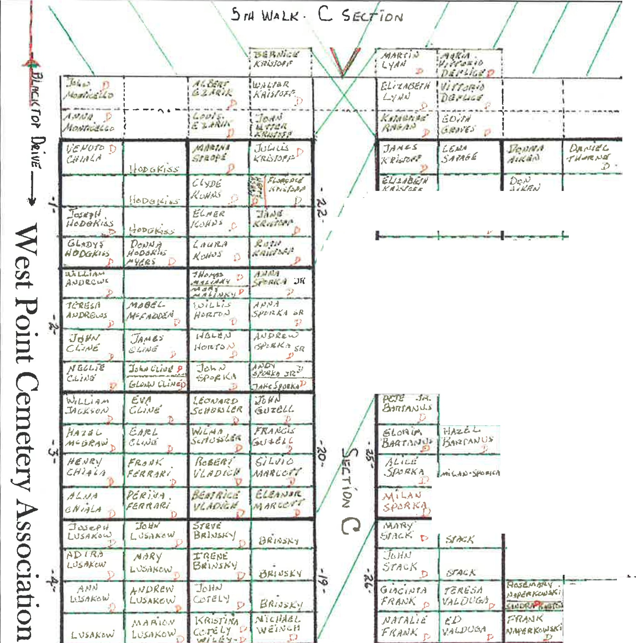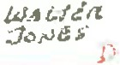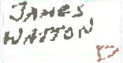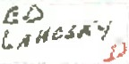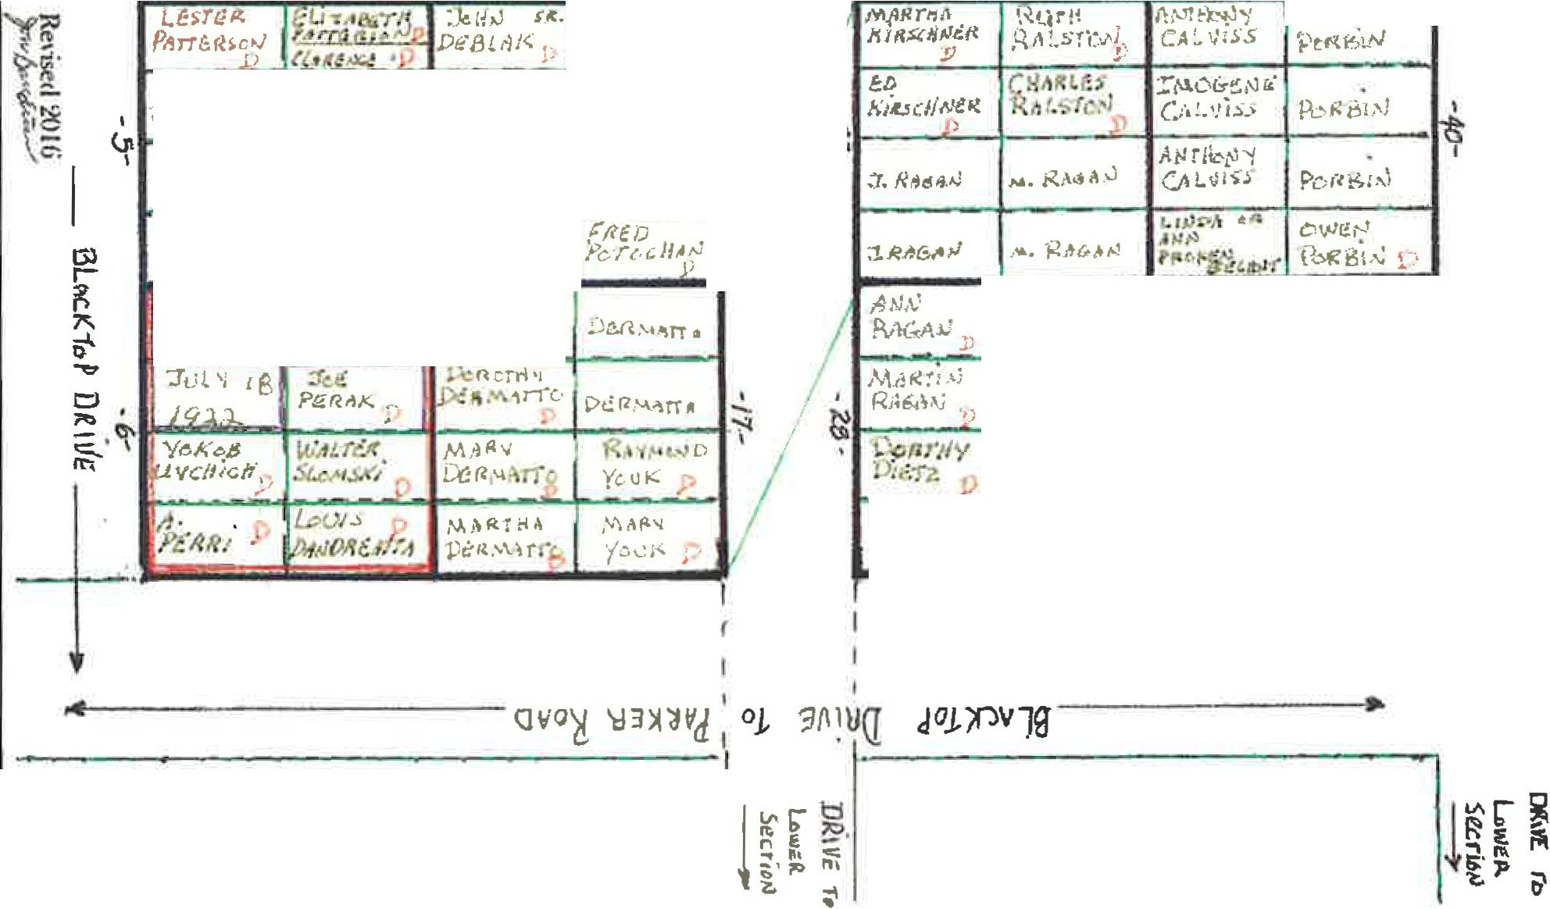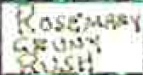

*Ds!TZ* ;,,

£:f A l. " C,!t j '1'! ; )

\) ,..:,/\l p

Rt·s: o

,,, ,'

./

1

.*•*-*,!]*

0

..

##### /



.,.I,

r

*· c:;*

0

.,,

c(

J

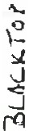"**3**'

C:

In

*I*

*I*

*I*

uI

**a***'1***:**

**M** ...

.J

..

***' /JA,.,ie,.***

***W'11'f(,O***

*I* ***'f*** ?._ ***1***

***(!L I* LJf*Se/rl***

- - -- I--

1

**L . . . .** - - - - - - - •·• ·-

!

*I*

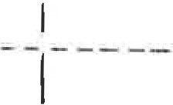· I- - - - -

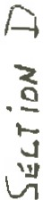- - - -· -- I- -

I

I

__I _

- - - - **_ _I** _-_-.

·-__

1 I-- -- - -

. I

I .

l

I

_ _ _ --·- -- .

1-- - - ... -- ......- ,.. ..

,. --------- --

j

1

.

_ _ _ . .._..

-- -1---- --

1

I

----· - - - - - - -

--1- ·-- -

1- - - - -

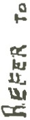I _ _ l---- --· - ---- --' - -- ----

1

·-- - - - - - -

- - - ·-I

'

-- - -

-- -· -- I- -- --

l J_ .

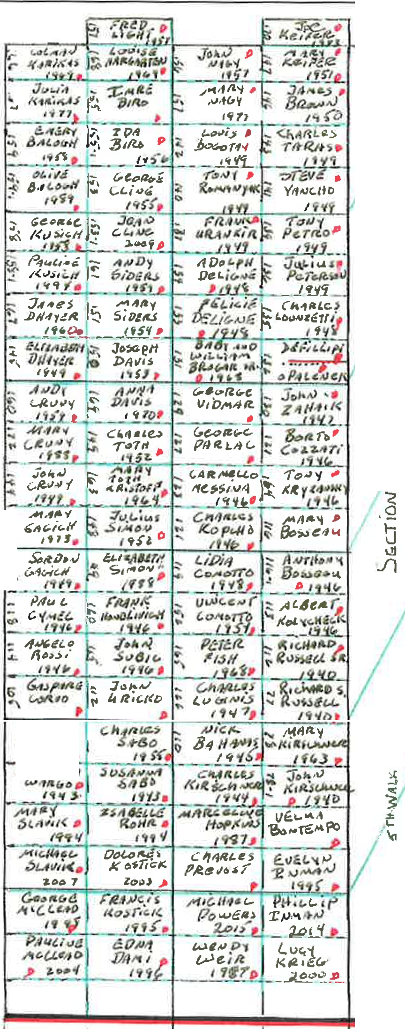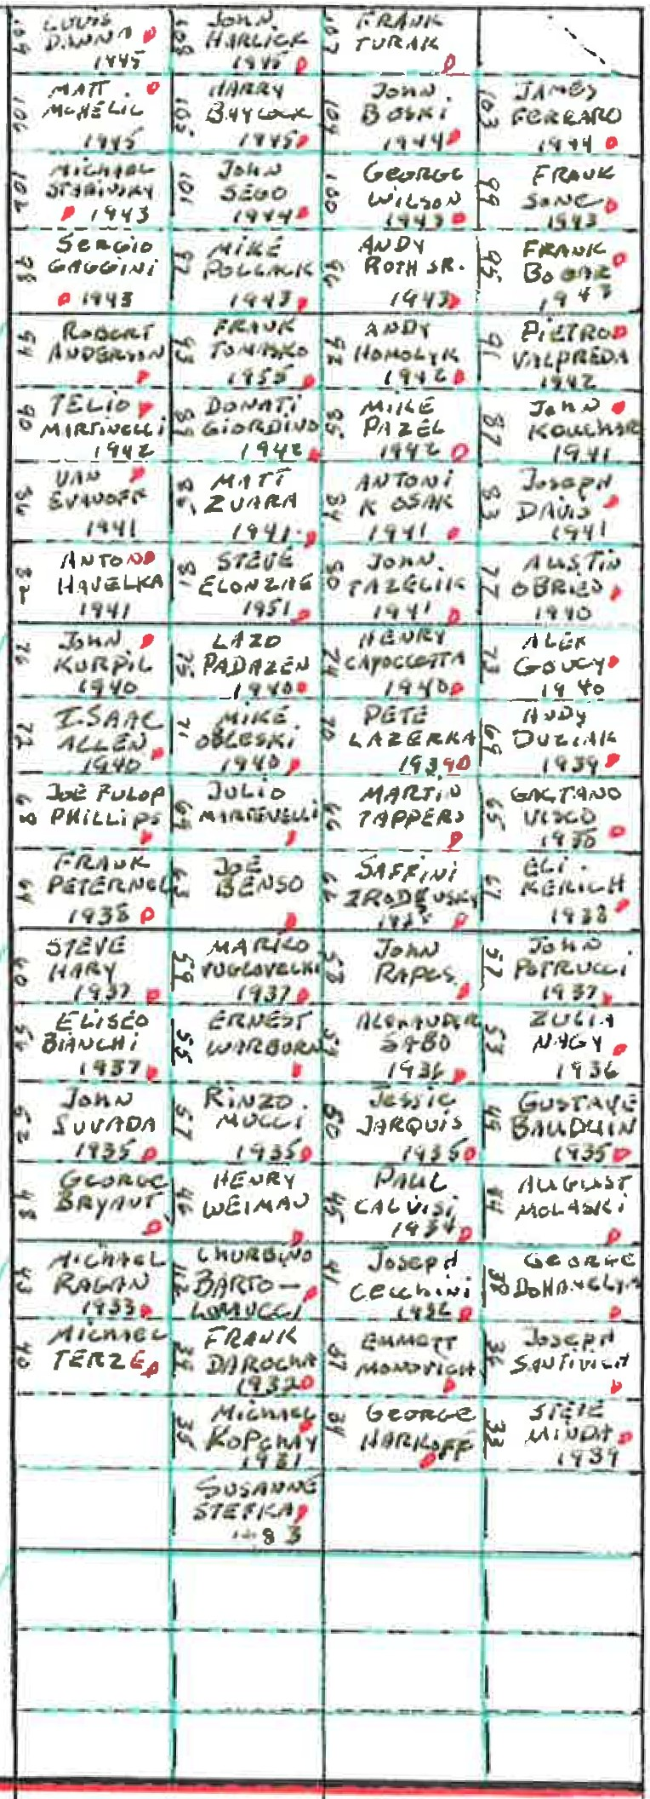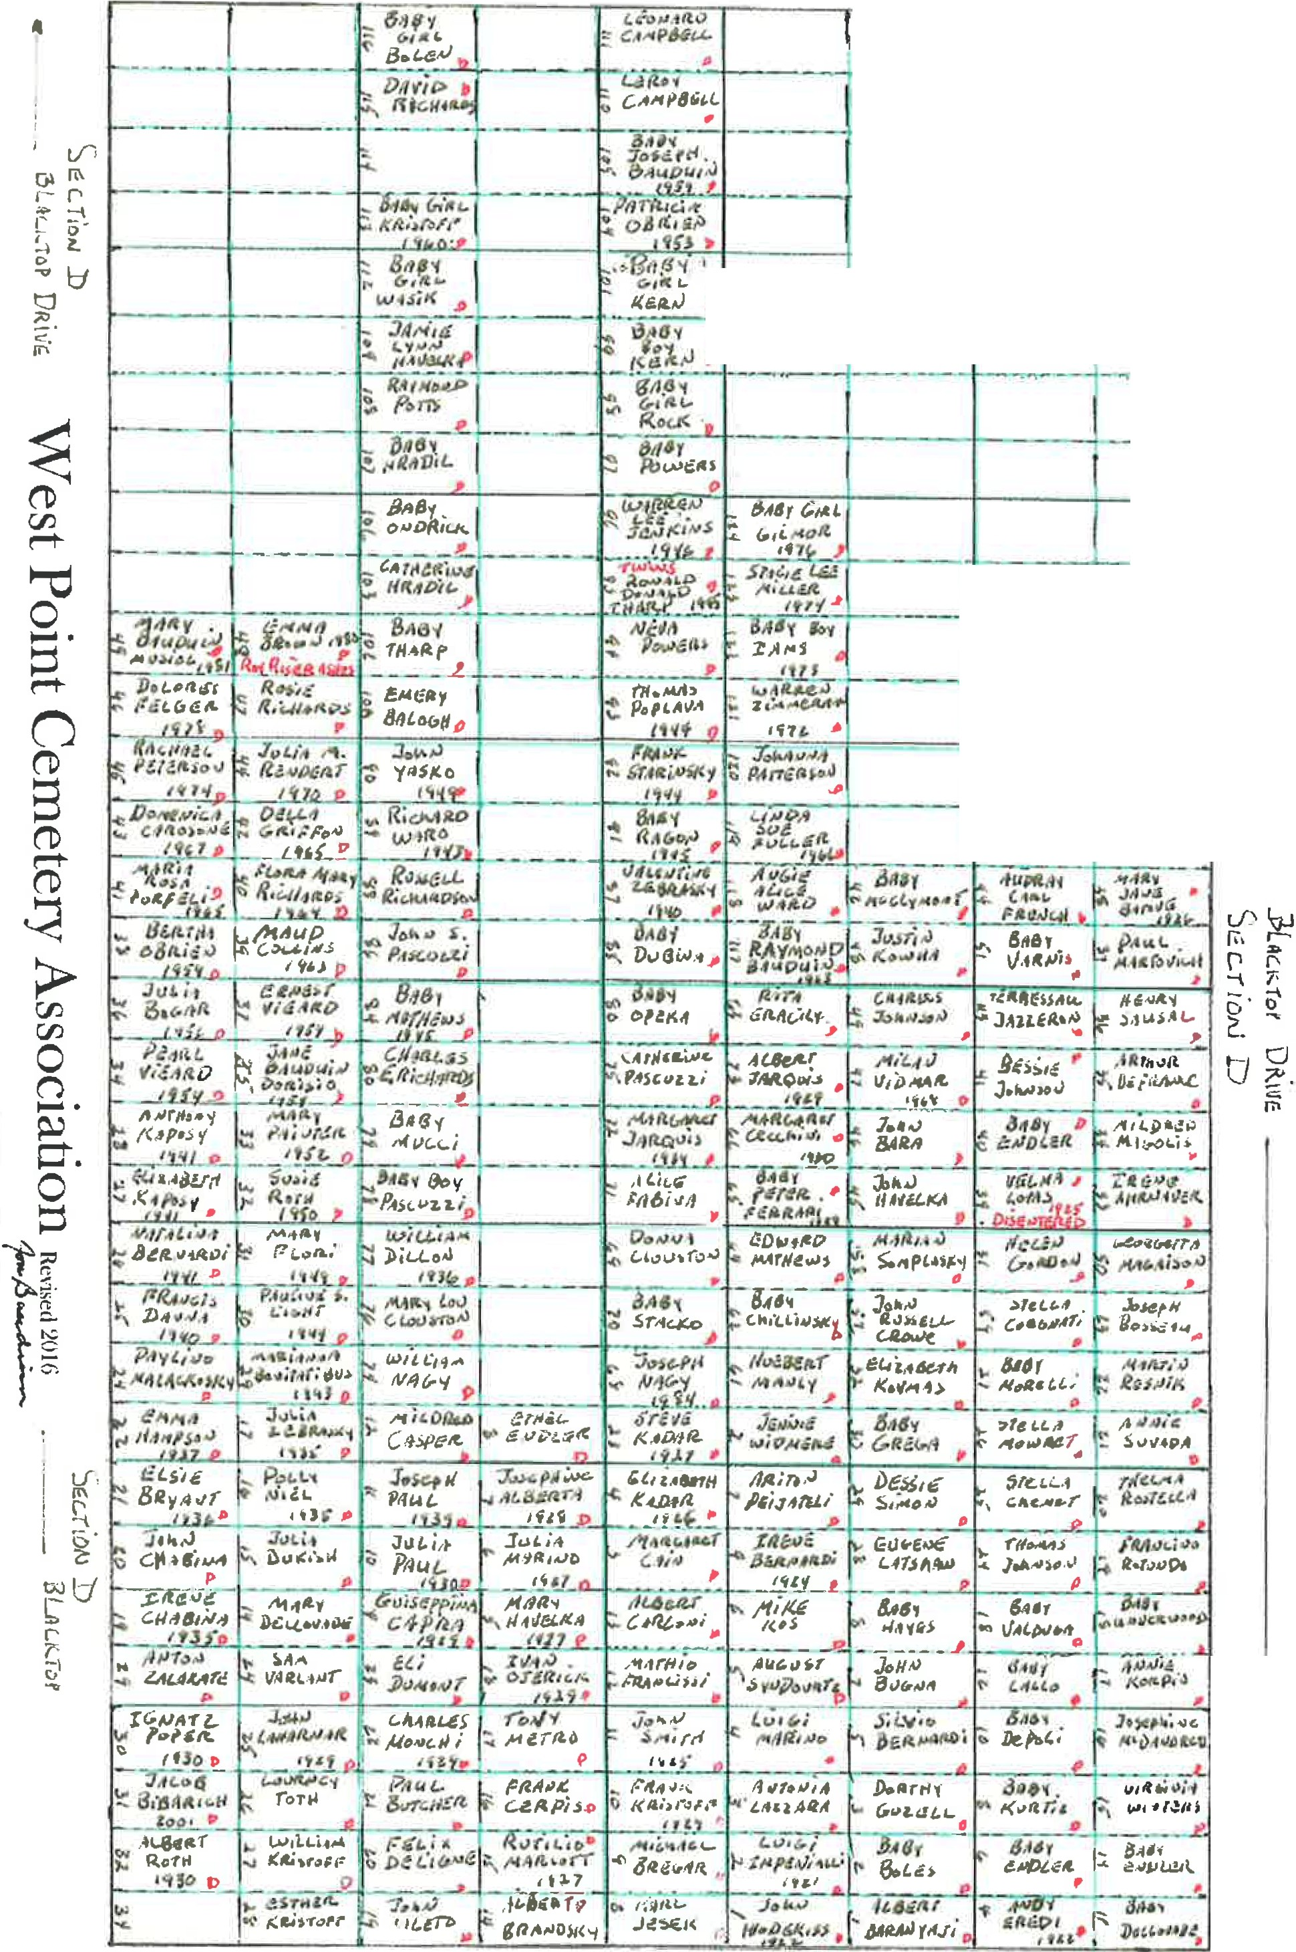

I

_ j_ -- --

r-- - t

1

*C1*

,

f

I

I

-+-- - - - ---- - - -

r:J.

1s,::-,.

I

##### i

###### 1

-j.I

*l*

'- - - - -·-

**r**

- - -

u

I

(j

**t- - - - - + - - - - + - - - - --1-- - ·-**

**1- - - - -+ - - - - -1- - -- - - 1·- - -**

- **0-** - - - - - - - - - - - - - -----

l - - - - --+I- - - - - +-- · - - -

L•

**r---**- --- - - - -- - - - +--- - - -

1- ------- --··--t-- I

**r**

*v.,...,,.., g "' J111te-s E .* luAt.-r " · -.. Hel'!f'IV:0

- - - - - - t--- -- - - - - - - - ----1, 1

t--- - - - +-- - - - -1- - - - - - - - - - · -

,q

"', *SA LVo ..* &/-ii"- , *[;bfi!Je.y*

*PtU.vr/J* I'<\ *Elf"tcrr* 1-o *c»,.,i1t:*

N *€.DiV"t/l.PJ* "°' *ttlt;ic,;1-11,,j* '< *K* 1,vc,

*3 ENN*

2 --- - - 4---- - - -1--- - - --- - -

·5

*C1*

._ _ _,l''-"''='-.t:..1-4>-

.... •--+- - - - s";.....1- - -·· -

*v*IJ*,*j

·- - ..--- "··- - - - - -- -·- - - - - - - - ... **t**

~~-~~- ---i - --

t-- - - -t-- - - - -1-- - - - +-- - - -

..0....

0,:

**l.!.l**

u.

u,

--- ----!------ +----- -+----

**1- - - - - +- - - - - +- - - - - --1-- - - - ----**

.\.ll.

•;.

*C.*

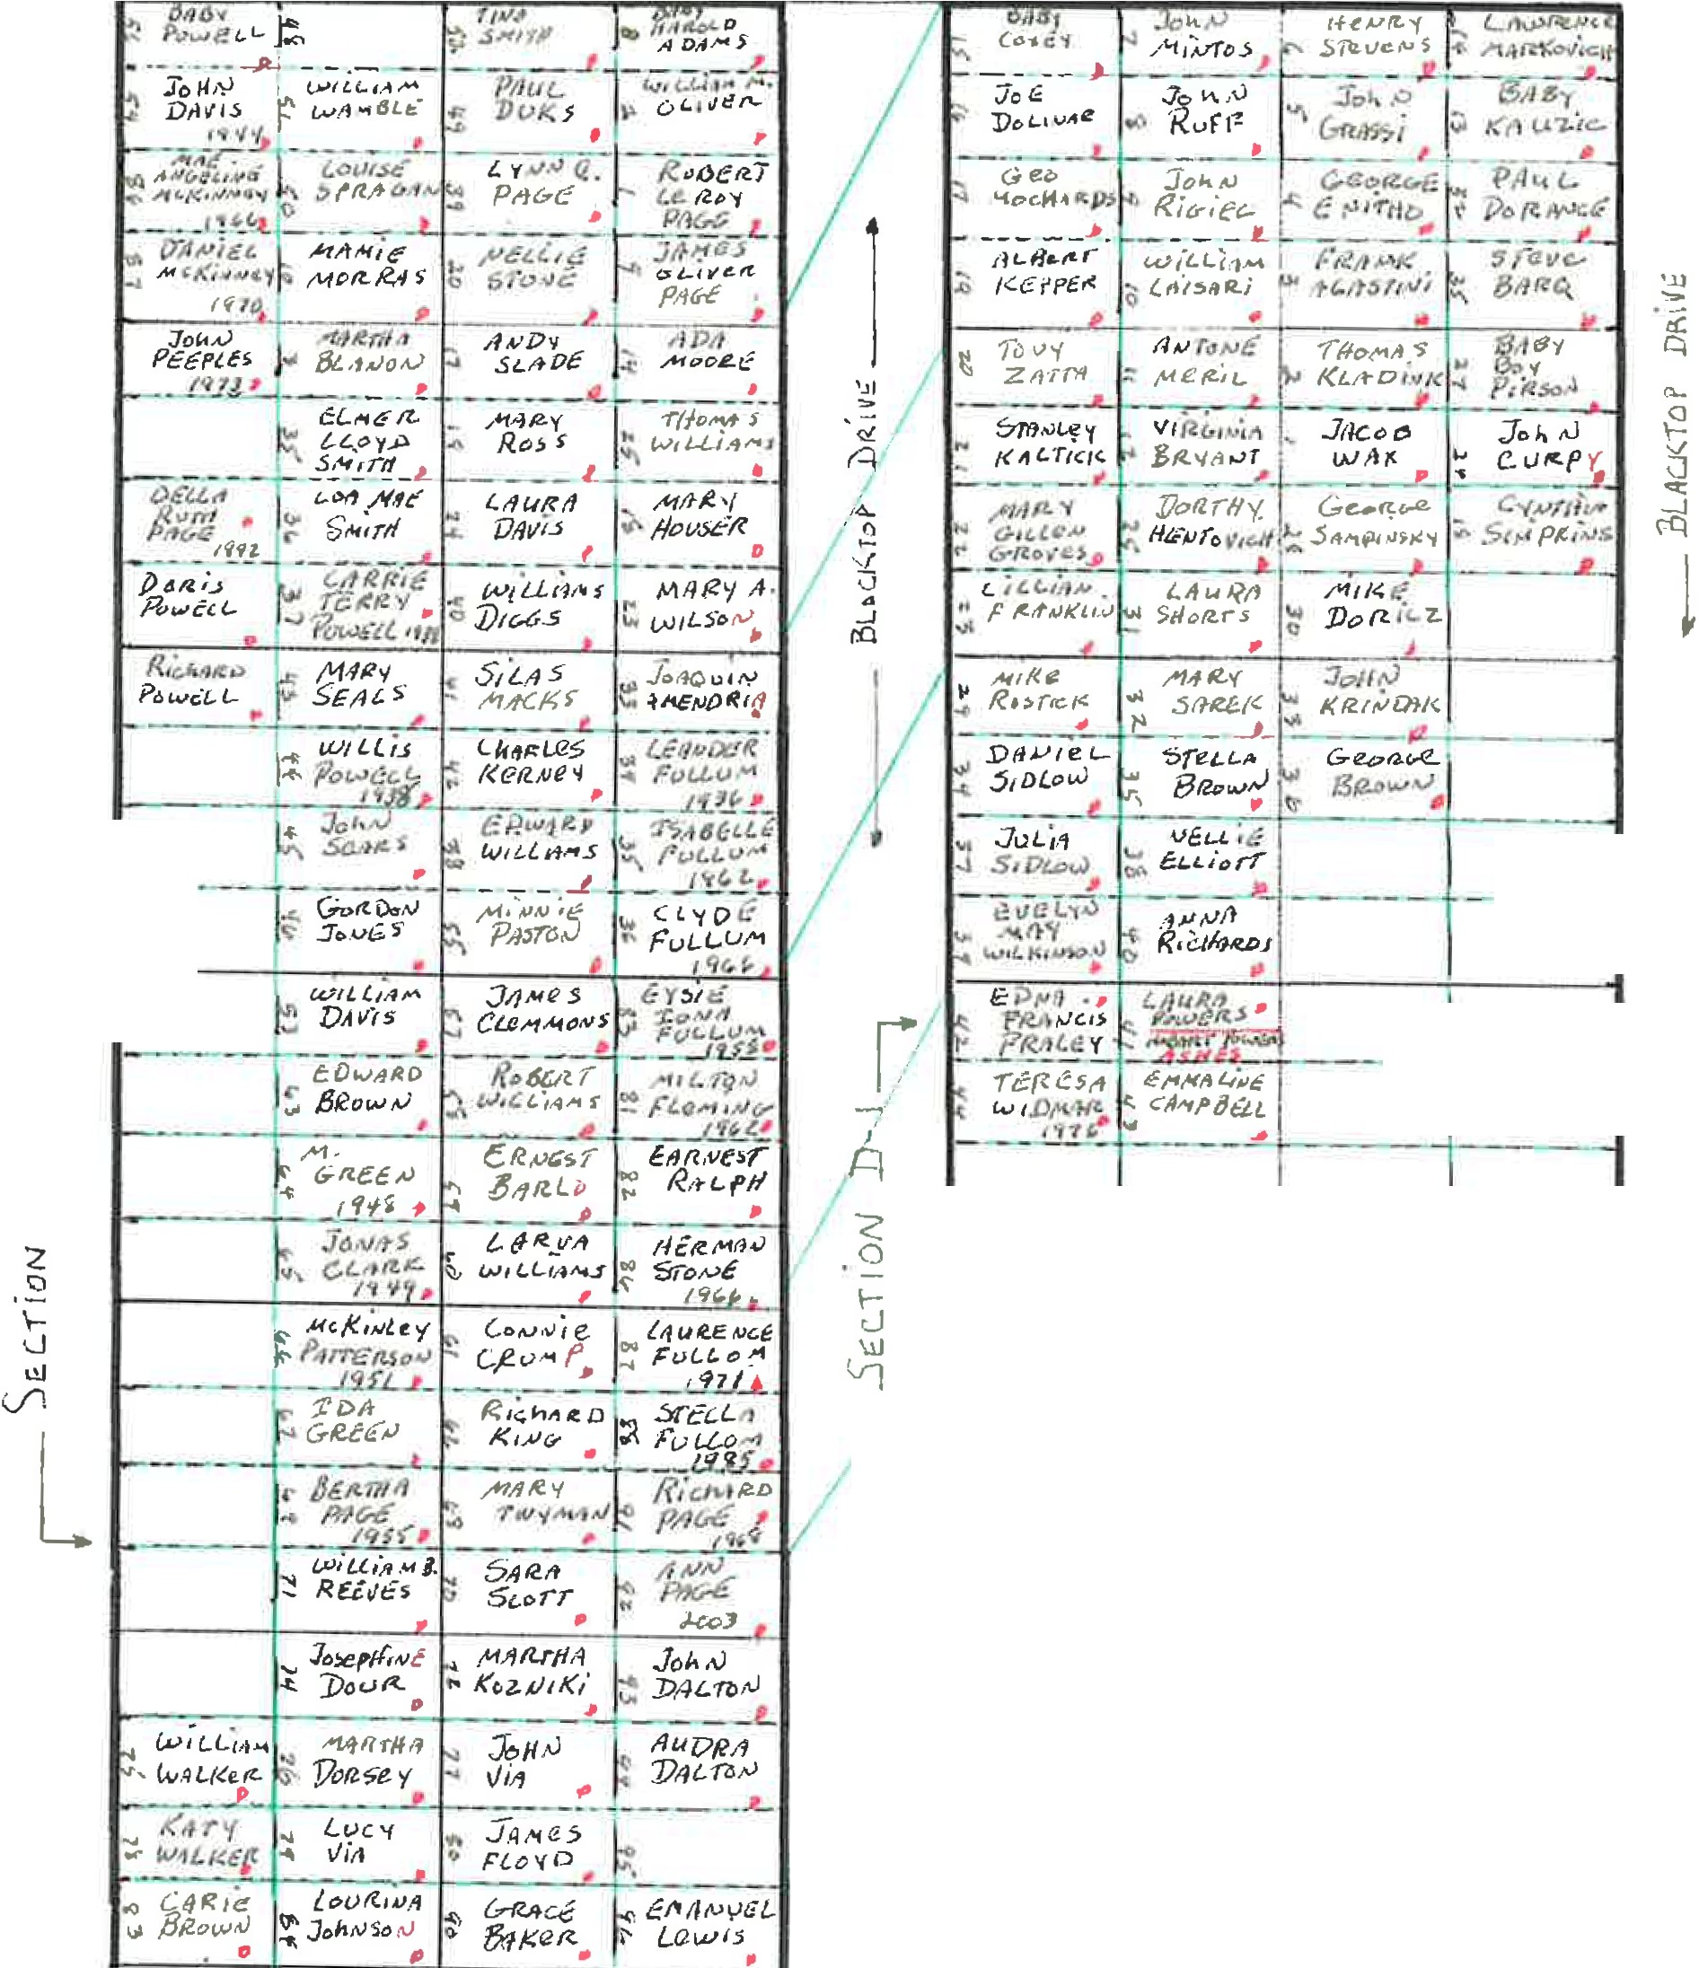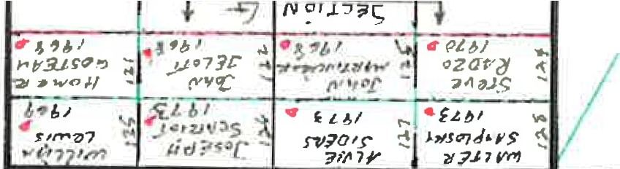

**cctl l- - -+----+--·--t--1**

*I* ...- - -- - + - - - ---i-- - - - - t·---- - -

**1- - - - - ·1- - -- - - - - 1--** --- - -+- - - --

**t Sr. *.Jo!ir,15* t**

__ T' ;--- -- (, ----- - ----- **j**---- -- -- - - J - -

|  |  |
| --- | --- |
|  | |
| L-----' -- -- --'---- -- ------ I _  I---- - I l---------- I  ----- | - . -"' - -- - ... . -  **f** |
|  |

l - -----'- -- - J

- --- - -.- - -- - - - - -·- -- - -- · - - -- - --\- - ----

·

! __ )

-- --- ._ L __ - - -' ---- - - -- '•

_ --1! _ .

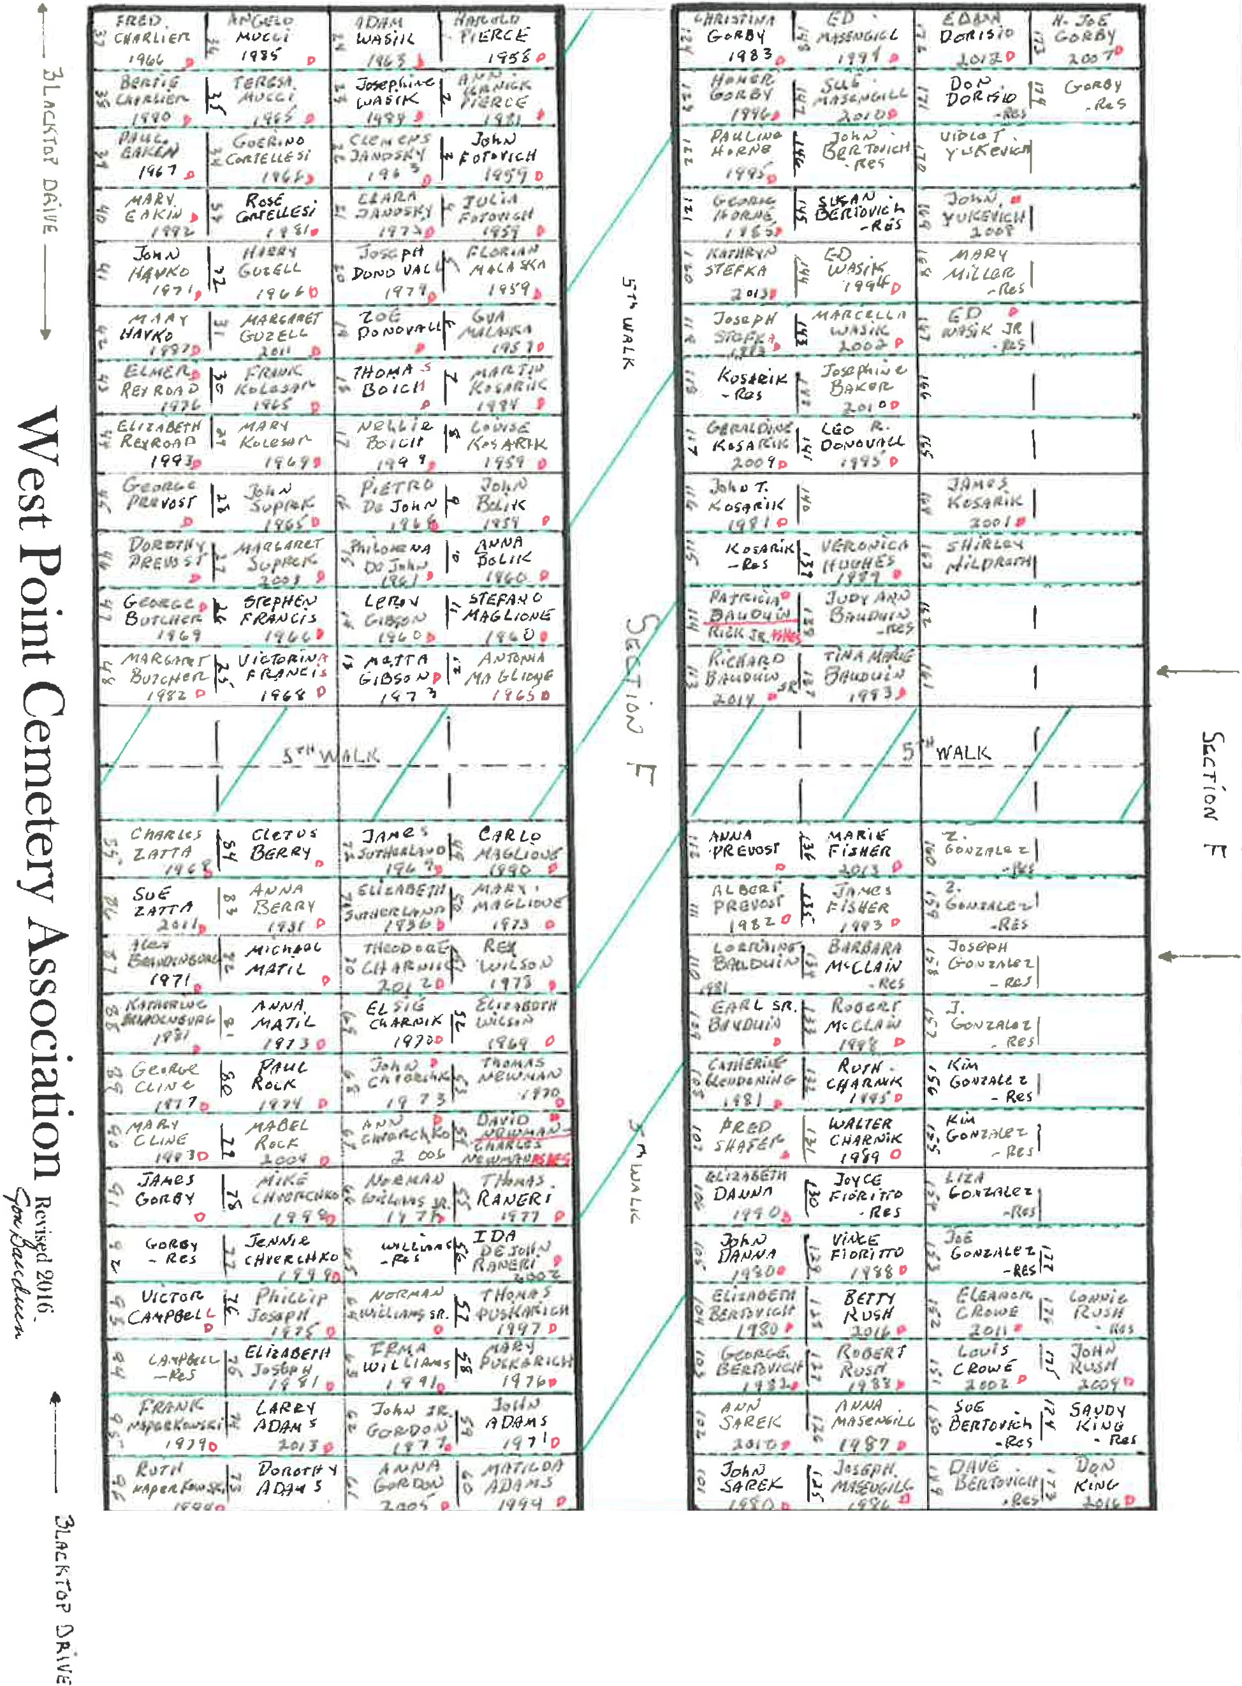

,_1 _

, _ .......... _

[, _.

r - -·

- *:Jf" i!l:*

,.,,,

*I*

*.... r o ,: p /1*

r

11- 1I -

**t---- - -'- - - - - -- - - - -t**

-_-L-I -_----1--_-_--_ -

lf)

f'\

Q

5'

2:..

*I*

-+--

*I*

*I*

***e****1/****/****e****u****.,,****4****,,****i****.,****f****,****r****,_****//****.,*

f ,,,,.,

***/t.l'-"***

.x., *3" - - ,* .,.,,,,;***0***_***-1***,.***0***,-,,.

J

*,vew,<,11.J* t..,H, /c,1

*_ .J,!;EL, ;t. _ J.oo _ ,.:lc...O; ­*

*(.qv,*

*Jl;,1/0.>'(*

J.,c,,

*";k We* -----

*llt1dh*

*o;,1,ll_ iR<s*

*J4J),(,,1p,,1.L1.<,>* s,2. ( *F'fl;IV l:,tor..v*

,1o,;, •

*Otl- IZ-* ***vrcT,,;,***

.).o., **g** *o;t.•*

*(lriltt'1*

,I , ,µic;,,

*CII flt,Jecl- (et. NTillQ*

*;t;,>ot I* -ho- *>,o,,* ;

*sr,;,u* r *Red tir* "· *M /Y;; /£-:-*

*Cti* ***f4 /.*** '- I

J

*7},vc;;t* ***Co-5"#.,.IAIO***

- */7.s 1ev$*

*G11f!.t- ;r.,..,i:.*

*.,.,,.,, (_.*

*-f{o*

*&1,ten:E*

*'l?t,vclf ro.jk{l. oe , //(<#*' *;J,.,,,,,,.*

-- - ...!!

- *•$*

*- -.!. ..lo*-*0oJ .*

*r?";i;,,r*

*t' ff*"*/"*'*"*''"*'I*'' . *Fr{ohoN..alf$* •

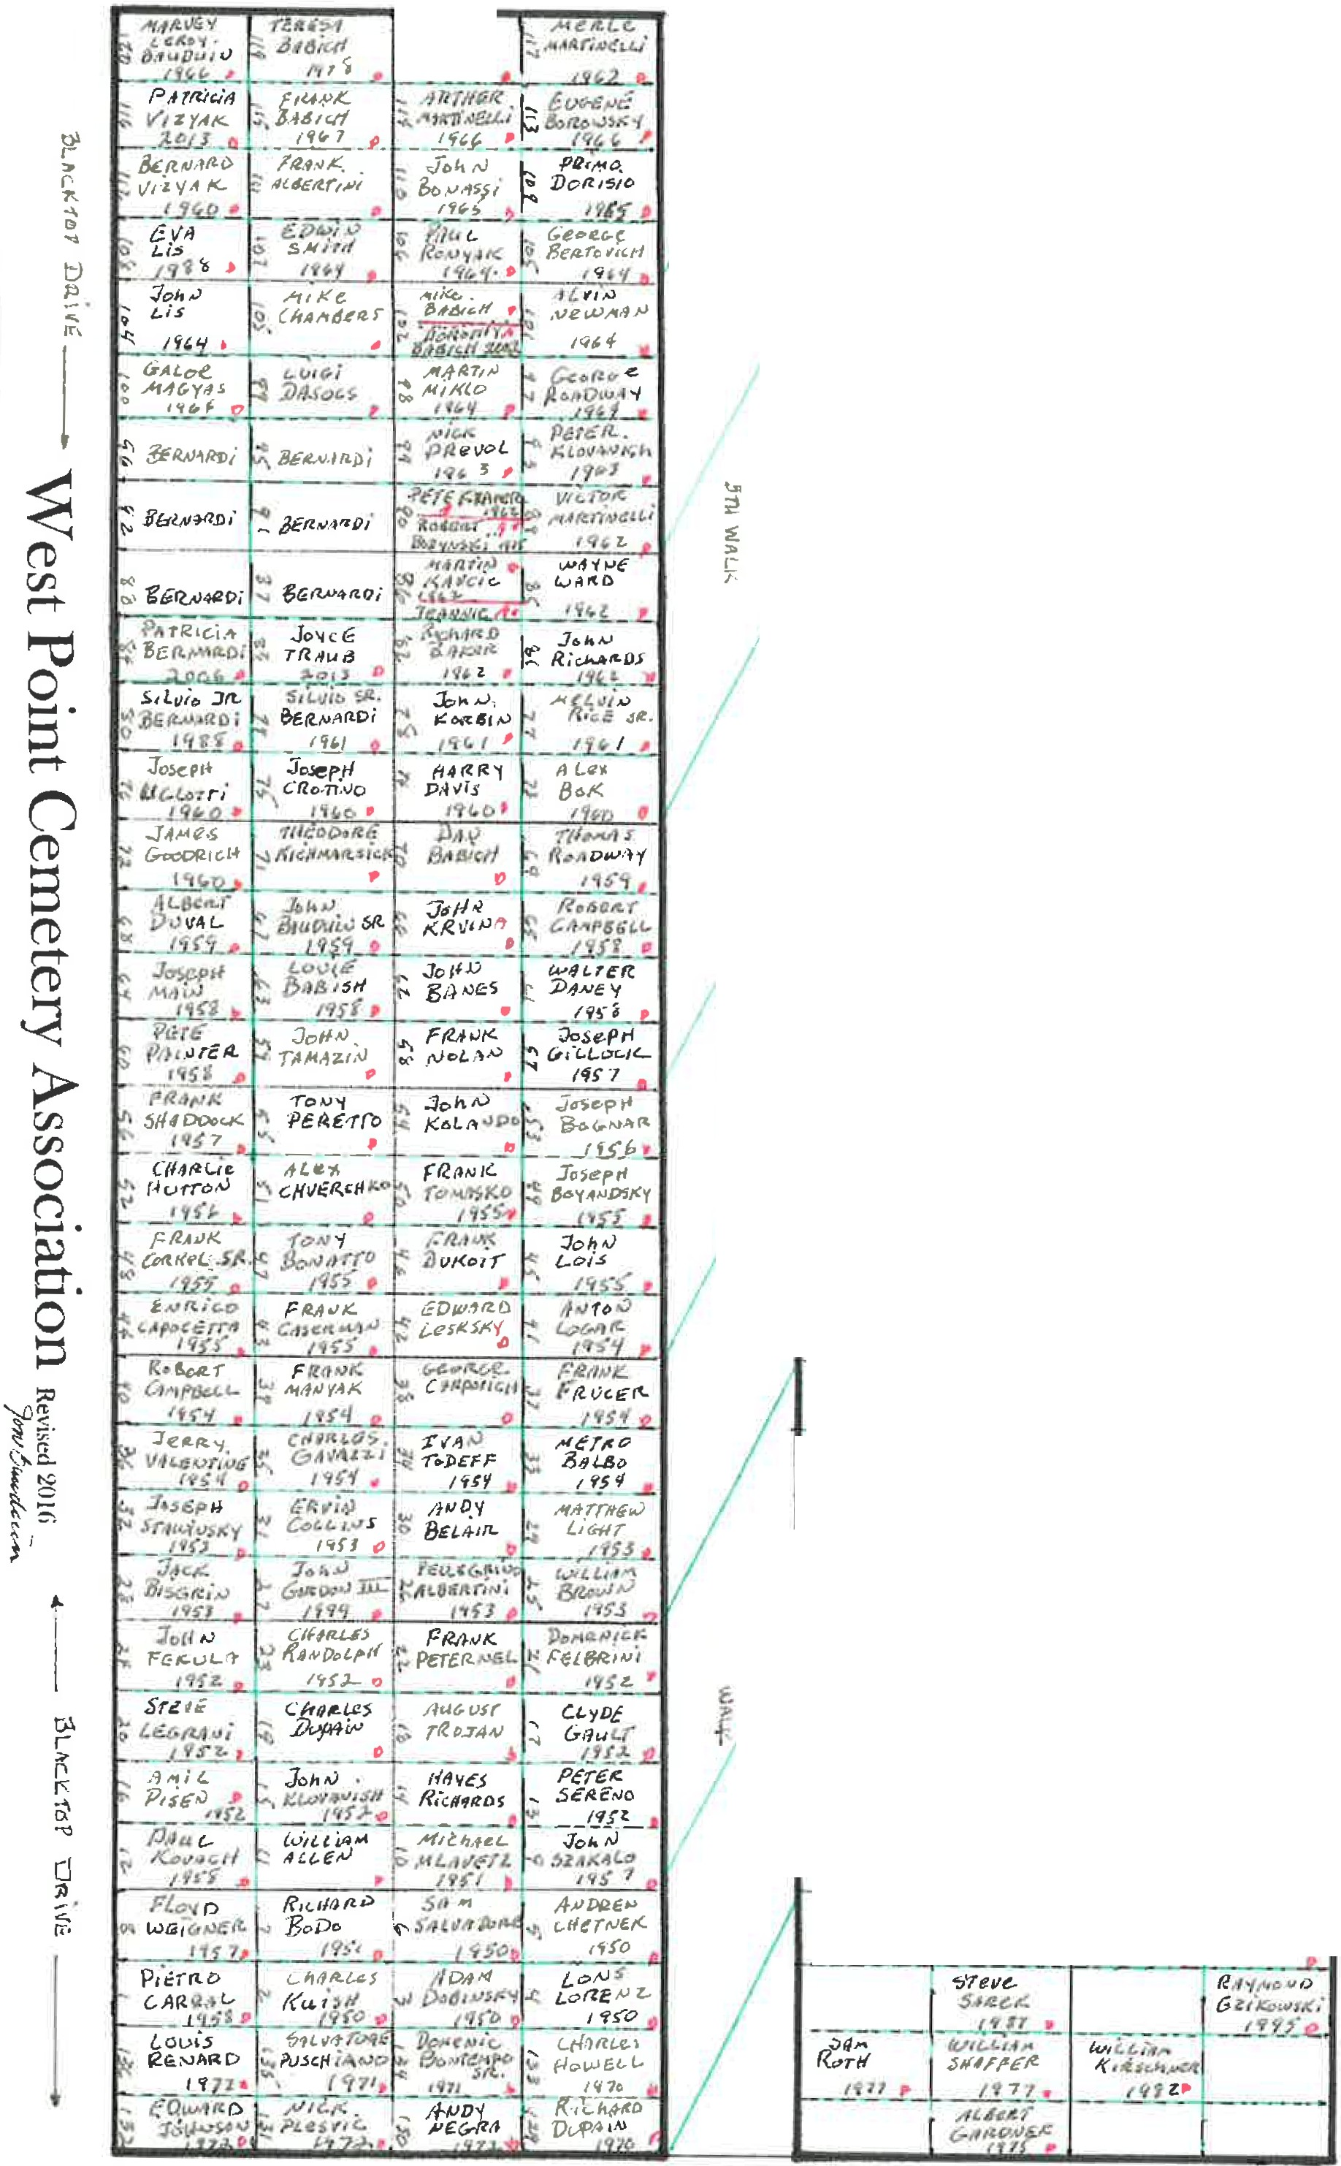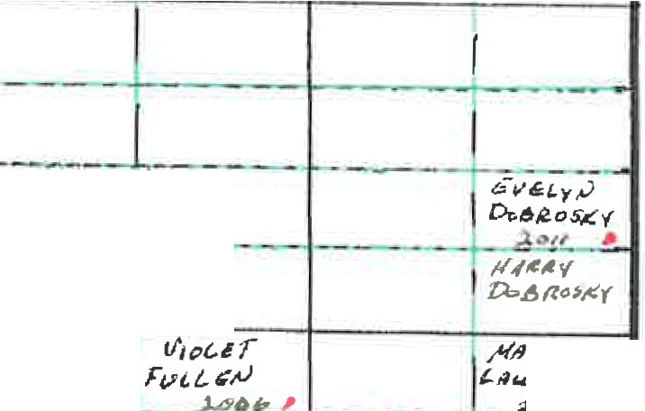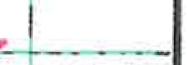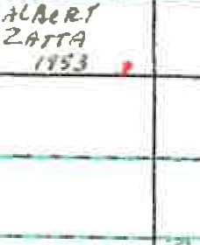

*llt:fl* ....,,, *w.1rr•tJ fJ.,r,,:* I*c;.z,i<.- ...,f(.*

"" 7

*C.h1111tc.5*

*(* ..,

***J (lt ,,,.J*** *&t1on<-e. ,'Unrft* •

*l'i'it>* II *I H V ,. l'r'i,*

*l>v/ JI ,',",*

# esPtoint

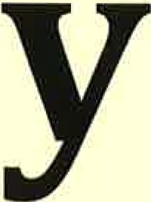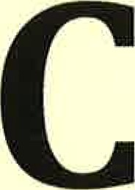 **emeter**

**As-**

**so ciati on**

###### Alphabetical

|  |  |  |  |
| --- | --- | --- | --- |
| Name | Section | Grave Number | Date of Death |
| ADAMS , BABY HAROLD | GC | 2 |  |
| ADAMS, BERTHA | C | 42 |  |
| ADAMS, JOHN | F | 60 | 1983 |
| ADAMS , LARRY | F | 24 | 1984 |
| ADAMS, MALTILDA | F | 124 | 1996 |
| ADAMS , STEVE | C | 41 |  |
| AGASTINI , FRANK | Dl | 2 |  |
| AHRNAVER, IRENE | D | 50 |  |
| AIKEN, DON | C | 44 |  |
| ALBERTA,JOSEPHINE | D | 6 |  |
| ALBERTINI, FRANK | G | 107 |  |
| ALBERTINI, PELLIGRINO | G | 22 |  |
| ALLED, WILLIAM | G | 7 | 1950 |
| ALLEN, ISSAC | C-1 |  |  |
| AMENDRIA, JOAQUIN | GC | 34 | 1962 |
| ANDERSON,ROBERT | C-1 |  |  |
| ANDREWS, DELBERT | B | 5 | 1968 |
| ANDREWS, HAROLD "PETE" | B | 5 |  |
| ANDREWS, HELEN | A | 25 |  |
| ANDREWS, LEROY | B | 4 | 1988 |
| ANDREWS, NELLIE | B | 5 | 1986 |
| ANDREWS, SHERRI | B | 5 | 1965 |
| ANDREWS, STAN | A | 25 | 1965 |
| ANDREWS, TERESA | C | 21 |  |
| ANDREWS, WILLIAM | C | 21 |  |
| ANDREWS. LILLIAN | B | 4 |  |
| APPLEBY, GAVIN EDWARD | A | 3 | 1980 |
| APPLEBY , GEORGE | A | 3 |  |
| APPLEBY , GEORGE R. | A | 3 |  |
| APPLEBY, KATHRYN | A | 3 | 1994 |
| ARMSTRONG, HARRY | A | 23 | 1985 |
| ARMSTRONG, TWILA | A | 23 |  |
| BABARICH, JACOB | D | 32 | 1980 |
| BABICH, DAN | G | 66 |  |
| BABICH, DOROTHY | G | 98 | 1963 |
| BABICH, FRANK | G | 111 | 1964 |
| BABICH, MIKE | G | 102 | 1964 |
| BABICH, TERESA | G | 115 |  |
| BABISH, LOUIE | G | 59 |  |
| BABY BOY TWINS- RONALD and DONALD TH | D | 94 | 1944 |
| BAHANAS, NICK | C-1 |  |  |
| BAKER,GRACE | GC | 95 |  |
| BAKER, JOSEPHINE | F | 141 | 1989 |

|  |  |  |  |
| --- | --- | --- | --- |
| Name | Section | Grave Number | Date of Death |
| BAKER, RICHARD | G | 78 | 1960 |
| BALBO, METRO | G | 29 | 1953 |
| BALOGH, EMERY | D | 90 | 1943 |
| BALOGH, EMERY | C-1 |  |  |
| BALOGH, OLIVE | C-1 |  |  |
| BANES, JOHN | G | 58 |  |
| BANKS, JAMES B. | GC | 98 |  |
| BANYAS,NANCY | B | 29 |  |
| BARA, JOHN | D | 49 |  |
| BARANYAJI, ALBERT | D | 44 |  |
| BARDELL!, BILL | A | 19 |  |
| BARDELL!, MARY | A | 19 |  |
| BARDELL!, PAUL | A | 19 | 1935 |
| BARDELL!, ROSE P. | A | 19 | 1951 |
| BARLO,ERNEST | GC | 60 |  |
| BARONICK, RUDPOLH | B | 7 | 1979 |
| B ARONICK, STELLA | B | 7 | 2000 |
| BARQ, STEVE | Dl | 27 |  |
| BARTANUS, GLORIA | C | 42 |  |
| BARTANUS,HAZEL | C | 41 |  |
| BARTANUS, PETE JR. | C | 42 |  |
| BARTANUS, PETE SR. | C | 42 |  |
| BARTOLOMUCCI, CHURBINO | C-1 |  |  |
| BATOVE, MARY JANE | D | 37 |  |
| BAUDUIN, ADOLPHINE | B | 3 | 1986 |
| BAUDUIN, BABY JOSEPH | D | 104 |  |
| BAUDUIN, BABY RAYMOND | D | 63 | 1929 |
| BAUDUIN, EARL SR. | F | 108 |  |
| BAUDUIN, GUSTAVE | C-1 |  |  |
| BAUDUIN, JOHN SR. | G | 63 |  |
| BAUDUIN, JOSEPH | B | 3 | 1953 |
| BAUDUIN, LUCY M. | B | 3 | 12/25/2015 |
| BAUDUIN, MARVEY LEROY | G | 116 | 1960 |
| BAUDUIN, PATRICIA | F | 114 | 2015 |
| BAUDUIN, RICHARD JR. *{ASHES]* | F | 113 |  |
| BAUDUIN, RICHARD SR. | F | 112 | 1982 |
| BAUDUIN, TINA MARIE | F | 136 | 1993 |
| BAUDUIN, WALLACE E. | B | 3 | 7/01/2005 |
| BAYLOCK,HARRY | C-1 |  |  |
| BELAIR, ANDY | G | 26 |  |
| BENKO, JOHN | A | 3 |  |
| BENKO, VIKI | A | 3 |  |
| BENSE, JOE | C-1 |  |  |

|  |  |  |  |
| --- | --- | --- | --- |
| Name | Section | Grave Number | Date of Death |
| BOSSEAU, LIBBY | B | 28 |  |
| BOSSEAU, **MARY** | C-1 |  |  |
| BOSSEAU, PAUL | B | 28 |  |
| **BOWERS, ELLA MCBRIDE,** W/0 F.P. | H |  | 1864-1881 |
| BOYANDSKY,JOSEPH | G | 45 | 1954 |
| BOZVNSKI, ROBERT *(ASHES)* | G | 90 |  |
| BRANDEDBURG,ROBERT | B | 28 |  |
| BRANDENBURG,ALEX | F | 89 | 1993 |
| BRANDSKY, ALBERT | D | 111 |  |
| BREGAR, MICHAEL | D | 8 |  |
| BRESKO, JOHN | B | 21 | 1954 |
| BRINSKY, IRENE | C | 19 |  |
| BRINSKY, STEVE | C | 19 |  |
| BROGAR, WILLIAM SR., and BABY | C-1 |  |  |
| BROWN, EDWARD | GC | 64 | 1949 |
| **BROWN, EMMA** | D | 48 |  |
| BROWN, GEORGE | Dl | 14 |  |
| BROWN, JAMES | C-1 |  |  |
| BROWN, STELLA | Dl | 38 |  |
| BROWN, WILLIAM | G | 21 | 1952 |
| BRUNNER,ROBERT | **A** | 18 | 1941 |
| BRYANT, ELSIE | D | 20 | 1935 |
| BRYANT, GEORGE | C-1 |  |  |
| BRYANT, VIRGINIA | Dl | 25 |  |
| BUGNA, JOHN | D | 5 |  |
| BUTCHER,GEORGE | F | 48 | 1969 |
| BUTCHER,MARGARET | F | 85 | 2011 |
| BUTCHER, PAUL | D | 20 |  |
| BUXTON, J.F., | H |  | 1850-1919 |
| **BUXTON, JANE ANN,** W/0 RICHARD | H |  | 1827-1906 |
| BUXTON, RICHARD, S/OMRON&SARAHWILEY | H |  | 1823-19-- |
| CAIN, MARGARET | D | 13 |  |
| CALVISI , PAUL | C-1 |  |  |
| CAMPBELL, EMMALINE | Dl | 6 |  |
| CAMPBELL, HARRY | G |  | 2007 |
| CAMPBELL,LEONARD | D | 110 | 1954 |
| CAMPBELL, LEROY | D | 105 | 1953 |
| CAMPBELL, ROBERT | G | 36 | 1953 |
| CAMPBELL, ROBERT | G | 61 | 1957 |
| CAMPBELL, ROBERT E. | G |  |  |
| CAMPBELL, VICTOR | F | 95 | 1994 |
| CAMPELL, JANET | G |  | 2016 |
| CAPOCCETTA,HENRY | C-1 |  |  |

|  |  |  |  |
| --- | --- | --- | --- |
| Name | Section | Grave Number | Date of Death |
| BENSON, ELIZABETH | B | 9 |  |
| BENSON, JOHN | B | 9 |  |
| BENSON, JOSEPH | B | 9 |  |
| BERNARDI, IRENE | D | 6 |  |
| BERNARDI, NATALINA | D | 25 |  |
| BERNARDI, PATRICIA | G | 80 | 1960 |
| BERNARDI, SILVIO SR. | G | 75 |  |
| BERNARDI, SILVO | D | 3 |  |
| BERNARDI, SILVO JR. | G | 76 | 1960 |
| BERRY,ANN | F | 82 | 1973 |
| BERRY,CLETUS | F | 83 |  |
| BERTOVICH, GEORGE | G | 101 | 1964 |
| BERTOVICH, GEORGE | F | 102 | 1980 |
| BERTOVICH, MICHAEL | G |  | 1982 |
| BIANCHI, ELISEO | C-1 |  |  |
| BIRO, IDA | C-1 |  |  |
| BIRO, IMRE | C-1 |  |  |
| BISGRIN, JACK | G | 24 | 1952 |
| BLANON, MARTHA | GC | 35 |  |
| BODO, RICHARD | G | 2 | 1971 |
| BOGAR, FRANK | C-1 |  |  |
| BOGAR, JULIA | D | 34 | 1941 |
| BOGATY, STEVE | C | 18 |  |
| BOGNAR, JOSEPH | G | 49 | 1955 |
| BOGOTAY, LOUIS | C-1 |  |  |
| BOICH, NELLIE | F | 16 | 1961 |
| BOICH, THOMAS | F | 17 | 1965 |
| BOK, ALEX | G | 69 | 1958 |
| BOLEN, BABY GIRL | D | 115 | 1960 |
| BOLES,BABY | D | 1 |  |
| BOLIK, ANNA | F | 11 | 1965 |
| BOLIK, JOHN | F | 10 | 1960 |
| BONASSI, JOHN | G | 106 |  |
| BONATTO, TONY | G | 43 | 1954 |
| BONITATIBUS, MARIANNA | D | 17 | 1935 |
| BONTEMPO, DOMENIC | C | 43 |  |
| BONTEMPO, DOMENIC SR. | G | 130 | 1962 |
| BONTEMPO, JOHN | G |  | 2005 |
|  |  |  |  |
|  | |
| BOROWSKY, EUGENE | G | 109 | 1964 |
| BOSKY, JOHN | C-1 |  |  |
| BOSSEAU, ANTHONY | C-1 |  |  |
| BOSSEAU,JOSEPH | D | 22 |  |

BONTEMPO, VELMA C-1

|  |  |  |  |
| --- | --- | --- | --- |
| Name | Section | Grave Number | Date of Death |
| CAPOCETIA, ENRICO | G | 40 | 1954 |
| CAPRA, GUISEPPINA | D | 23 | 1929 |
| CARLONI, ALBERT | D | 12 | 1925 |
| CAROSONE,DOMENCTA | D | 41 | 1959 |
| CARPOIVICH, GEORGE | G | 34 |  |
| CARRAL, PIETRO | G | 8 | 1972 |
| CASERMAN, FRANK | G | 39 | 1954 |
| CASPER, MILDRED | D | 11 | 1930 |
| CECCHINI, ELIO | B | 23 |  |
| CECCHINI, JOSEPH | C-1 |  |  |
| CECCHINI, MARGARET | D | 65 |  |
| CECCHINI, MARY SUVADA | B | 23 |  |
| CERPIS , FRANK | D | 15 |  |
| CHABINA, IRENE | D | 29 | 1930 |
| CHABINA, JOHN | D | 19 |  |
| CHAMBERS,, MIKE | G | 99 | 2013 |
| CHARLIER, BERTIE | F | 39 | 1992 |
| CHARLIER, FRED | F | 39 | 1967 |
| CHARNIK, RUTH | F | 131 | 1988 |
| CHARNIK, THEODORE | F | 67 | 1974 |
| CHARNIK, WALTER | F | 129 | 2016 |
| CHEMET, STELLA | D | 24 |  |
| CHETNEK, ANDREW | G | 4 | 1970 |
| CHIALA, ALNA | C | 19 |  |
| CHIALA, HENRY | C | 20 |  |
| CHIALA, VENUTO | C | 22 |  |
| CHILLINSKY, BABY | D | 61 |  |
| CHVERCHKO, ALEX | G | 47 | 1955 |
| CHVERCHKO,ANN | F | 66 |  |
| CHVERCHKO, JENNIE | F | 76 | 1981 |
| CHVERCHKO, MIKE | F | 77 | 1975 |
| CIMICATA, CATHERINE | H |  | 1893-1921 |
| CLARK, JONAS | GC | 66 |  |
| CLEMMONS, JAMES | GC | 58 |  |
| CLEMMONS, RUTH | B | 6 |  |
| CLINE, EARL | C | 20 |  |
| CLINE, EVA | C | 20 |  |
| CLINE, FOREST | H |  | 1894-1924 |
| CLINE, GEORGE | A | 23 |  |
| CLINE, GEORGE | C-1 |  |  |
| CLINE, GEORGE | F | 90 |  |
| CLINE, GLADYS | A | 24 |  |
| CLINE, GLENN | C | 20 |  |

|  |  |  |  |
| --- | --- | --- | --- |
| Name | Section | Grave Number | Date of Death |
| CLINE, GLENN JR. | A | 24 |  |
| CLINE, GLENN SR. | A | 23 |  |
| CLINE, JAMES | C | 21 |  |
| CLINE, JEAN | C-1 |  |  |
| CLINE, JOHN | C | 21 |  |
| CLINE, JOHN | C | 21 |  |
| **CLINE, MARJORIE,** W/0 FOREST, | H |  | 1897-1969 |
| D/0 WILLIAM & THERESA (GLUM) ANDREWS |  |  |  |
| CLINE, MARY | F | 91 |  |
| CLINE, MILDRED | A | 23 | 1937 |
| CLINE, NELLIE | C | 20 |  |
| CLINE, OLIVE GLADYS | H |  | 1916-1934 |
| CLINE, WAYNE T. | H |  | 1917-1939 |
| CLOUSTON, DONNA | D | 70 | 1984 |
| CLOUSTON, MARY LOU | D | 74 |  |
| COKEL, JOSEPH | H |  | 1933-1946 |
| **COKEL, THERESA,** D/0 JOSEPH & MARY TOLAR, | H |  | 1891-1973 |
| M. (1) RUDOLPH OGRAYENSEC M. (2) FRANK COKEL |  |  |  |
| COLLINS, ERVIN | G | 27 | 1952 |
| COLLINS, MAUD | D | 31 | 1954 |
| COMOTTO, LIDIA | C-1 |  |  |
| CORGNATI, STELLA | D | 27 |  |
| **CO\lkEL,** FRANK SR. | G | 44 | 1954 |
| CORTELLESI, GUERINO | F | 33 | 1966 |
| CORTELLESI, ROSE | F | 32 | 2011 |
| CORVO, GASPARE | C-1 |  |  |
| COSENTINO, PATRICIA | G |  | 1995 |
| COTELY, JOHN | C | 19 |  |
| COXEY,BABY | Dl | 16 |  |
| COZZATI, BORTO | C-1 |  |  |
| CROTINO, JOSEPH | G | 71 | 1959 |
| CROWE, ELEANOR | F | 151 | 2007 |
| CROWE, JOHN RUSSELL | D | 32 |  |
| CROWE, LOUIS | F | 173 | 2009 |
| CRUMP, CONNIE | GC | 61 |  |
| CRUMP, RICHARD | GC | 62 |  |
| CRUNY,ANDY | C-1 |  |  |
| CRUNY, ANTHONY JR. | A | 4 |  |
| CRUNY, ANTHONY SR. | A | 4 |  |
| CRUNY, CHARLES | C | 44 | 1998 |
| CRUNY, JEANETTE | A | 4 |  |
| CRUNY, JOHN | C-1 |  |  |
| CRUNY, MARY | C | 39 | 2003 |

|  |  |  |  |
| --- | --- | --- | --- |
| Name | Section | Grave Number | Date of Death |
| CRUNY, MARY | C-1 |  |  |
| CRUNY, THOMAS | A | 4 | 1949 |
| CURPY, JOHN | Dl | 18 | 1966 |
| CYMEL, PAUL | C-1 |  |  |
| DABROWSKI, IRENE MARY | H |  | 1913-1924 |
| DABROWSKI, JOHN H. | H |  | 1886-1954 |
| DABROWSKI, MARY., W/ O J OHN H. | H |  | 1890-1966 |
| DABROWSKI , VICTORIA CERLINA | H |  | 1918-1935 |
| DALTON, AUDRA | GC | 96 |  |
| DALTON, JOHN | GC | 94 |  |
| DAMI, EDNA | C-1 |  |  |
| DANDREATTA, LOUIS | C |  |  |
| DANEY, WALTER | G | 57 | 1956 |
| DANNA, ELIZABETH | F | 105 | 1982 |
| DANNA, FRANCIS | D | 24 | 1937 |
| DANNA, JOHN | F | 103 | 2010 |
| DANNA, LOUIS | C-1 |  |  |
| DASOCS, LUIGI | G | 83 | 1961 |
| DAVIS, ANNA | C-1 |  |  |
| DAVIS, HARRY *(ASHES)* | G | 70 |  |
| DAVIS, JOHN | GC | 86 |  |
| DAVIS, JOSEPH | C-1 |  |  |
| DAVIS, JOSEPH | C-1 |  |  |
| DAVIS, LAURA | GC | 40 |  |
| DAVIS, WILLIAM | GC | 63 | 1948 |
| DEBLAK, JENNIE | C | 18 |  |
| DEBLAK, JOHN SR. | C | 18 |  |
| DEBLAK, PAIULINE | C | 17 |  |
| DEBLAK, WILLIAM | C | 18 |  |
| DEFILLIPI, MR. | C-1 |  |  |
| DEFLICE, MARIA VITTORIO | C |  |  |
| DEFLICE, VITTORIO | C |  |  |
| DEFRANCE, ARTHUR | D | 34 |  |
| DEJOHN, PHILOMENA | F | 14 | 1973 |
| DEJOHN, PIETRO | F | 15 | 1960 |
| DELIGNE, ADOLPH | C-1 |  |  |
| DELIGNE , FELICIE | C-1 |  |  |
| DELIGNE, FELIX | D |  |  |
| DELLOVADE, BABY | D | 56 |  |
| DELLOVADE, MARY | D | 24 | 1929 |
| DEPOLI, BABY | D | 8 |  |
| DEPOLI., GUERRERO | B | 3 |  |
| DEPOLI, HENRIETTA | B | 3 |  |

|  |  |  |  |
| --- | --- | --- | --- |
| Name | Section | Grave Number | Date of Death |
| DEPOLI, MARIA | B | 3 |  |
| DEPOLI, OSCAR | B | 3 |  |
| DERMATTO, DOROTHY | C | 17 |  |
| DERMATTO, MARY | C | 17 |  |
| DERMATTO, MATT | C | 17 |  |
| DERMATTO. MARTHA | C |  |  |
| DHAYER, ELIZABETH | C-1 |  |  |
| DHAYER, HENRY SR. | A | 20 |  |
| DHAYER,HENRY-DHAYER,DAN *(ASHES)* | A | 2 |  |
| DHAYER, JAMES | C-1 |  |  |
| DHAYER, MILDRED | A | 20 | 1990 |
| DIETZ, AUGUST | A | 2 |  |
| DIETZ, DOROTHY | C | 39 |  |
| DIETZ, HENRY | C |  |  |
| DIETZ, MARGAREY | A | 2 |  |
| DIGGS, WILLIAM S. | GC | 41 |  |
| DILEY, DARRELL "SAM" | B | 22 | 1975 |
| DILLON, WILLIAM | D | 76 |  |
| DINCH, EARL | G |  | 1987 |
| DOBINSKY, ADAM | G | 134 | 1972 |
| DOBROSKY, EVELYN | G |  | 2014 |
| DOHAMELYA,GEORGE | C-1 |  |  |
| DOLINAR, FRANK | B | 20 |  |
| DOLINAR, JOE | Dl |  |  |
| DOLINAR , MARY | B | 29 | 2000 |
| DONOVALL, JOSEPH | F | 19 |  |
| DONOVA LL, LEO R. | F | 139 | 1993 |
| DONOVALL , ZOE | F | 18 | 1999 |
| DORANC E , PAUL | Dl | 35 |  |
| DORICZ , MIKE | Dl | 33 |  |
| DORIS IO, EDNA | F | 169 | 2001 |
| DORISIO, JANE BAUDUIN | D | 33 | 1950 |
| DORISIO, PRIMO | G | 105 | 1964 |
| DOROCHA, FRANK | C-1 |  |  |
| DORSEY, MARTHA | GC | 79 |  |
| DORS EY, WALTER A. | GC | 99 |  |
| DOUR, JOSEPHINE | GC | 76 |  |
| DUBINA, BABY | D | 80 |  |
| DUKOIT, FRANK | G | 42 |  |
| DUKS, PAUL | GC | 39 |  |
| DUMOMT, ELI | D | 22 |  |
| DUPAIN, CHARLES | G | 15 |  |
| DUPAIN, GEORGE | G |  | 2011 |

|  |  |  |  |
| --- | --- | --- | --- |
| Name | Section | Grave Number | Date of Death |
| DUPAIN, RICHARD | G |  | 2006 |
| DUPAIN, ROBERT | G |  | 1995 |
| DUPAIN, WILLIAM SR. | G |  | 2005 |
| DUTKA, PETE JR. | B | 18 |  |
| DUTKA, PETE SR. | B | 18 |  |
| DUVAL, ALBERT | G | 64 | 1958 |
| DUZIAK, ANDY | C-1 |  |  |
| EAKIN, DALE WAYNE | B | 27 | 1981 |
| EAKIN, MARY | F | 41 | 1987 |
| EAKIN, PAUL | F | 40 | 1971 |
| ED BARDELL!, ED | A | 19 |  |
| EGHAZI, GABOR | B | 22 | 1970 |
| EGHAZI, GIZELLA | B | 22 | 1951 |
| EGHAZI, THERESA | B | 22 | 1984 |
| EICKENBURG, SHIRLEY NAOMI | B | 9 |  |
| ELLIOTT, NELLIE | Dl | 40 |  |
| ELONZAE,STEVE | C-1 |  |  |
| ELSIE BOGAR, ELSIE | B | 26 |  |
| ENDLER,BABY | D | 4 | 1926 |
| ENDLER,BABY | D | 39 |  |
| ENDLER,BABY | D | 11 |  |
| ENDLER,ETHEL | D | 7 | 1927 |
| ENITHO, GEORGE | Dl | 3 |  |
| ERACILY, RITA | D | 73 | 1930 |
| EREDI, ANDY | D | 38 |  |
| ERTLE, ELIZABETH | A | 20 | 1972 |
| ERTLE, LOUIS | A | 20 | 1968 |
| EVANOFF,VAN | C-1 |  |  |
| EZARIK, ALBERT | C |  |  |
| EZARIK, LOUIS | C | 22 |  |
| FABINA, ALICE | D | 79 |  |
| FANTONE, JOHN | B | 22 | 1976 |
| FANTONE, LORRAINE | B | 27 |  |
| FANTONE, WENDY | B | 22 | 1972 |
| FEKULA, JOHN | G | 20 | 1952 |
| FELBRINI, DOMENICK | G | 17 | 1952 |
| FELGER,DOLORES | D | 45 | 1967 |
| FERGUSON, ASHLEY E., S/OBUCHANAN&ALVIRABEARD | H |  | 1901 |
|  |  |  |  |
| FERRARI, BABY PETER | D | 64 |  |
| FERRARI, FRANK | C | 20 |  |
| FERRARO, JAMES | C-1 |  |  |
| FIORITTO, VINCE | F | 128 | 1988 |

|  |  |  |  |
| --- | --- | --- | --- |
| Name | Section | Grave Number | Date of Death |
| FIORONI, DENA | C | 39 |  |
| FISHER, JAMES | F | 133 | 1995 |
| FISHER, MARIE | F | 135 | 1998 |
| FLEMING, MILTON | GC | 82 | 1966 |
| FLORI, MARY | D | 30 | 1943 |
| FLOYD, JAMES | GC | 90 |  |
| FODOR, JUNE | G |  | 1990 |
| FODOR, THOMAS | G |  | 1987 |
| FORDA, STEVE | G | 114 | 1965 |
| FOTOVICH, JOHN | F | 4 | 1959 |
| FOTOVICH, JOSEPH | C | 43 |  |
| FOTOVICH, JULIA | F | 6 | 1984 |
| FOTOVICH, RUBY | C | 43 |  |
| FRALEY, EDNA FRANCIS | Dl | 44 |  |
| FRANCIS, STEPHEN | F | 25 |  |
| FRANCIS, VICTORIA | F | 84 | 1931 |
| FRANCISSI, MATHIO | D | 11 | 1929 |
| FRANK PETERNEL | C-1 |  |  |
| FRANK, GIANCITA | C | 41 |  |
| FRANK, NATALIE | C | 40 |  |
| FRANKLIN, LILLIAN | Dl | 29 |  |
| FRENCH,AUDRAYCARL | D | 51 |  |
| FRUCER,FRANK | G | 33 | 1953 |
| FRY, GEORGE SR. | B | 24 |  |
| FULLEN, VIOLET | G |  | 1953 |
| FULLER, LINDA SUE | D | 118 | 1963 |
| FULLOM, LAURENCE | GC | 88 | 1968 |
| FULLOM, STELLA | GC | 91 | 2003 |
| FULLUM, CLYDE | GC | 83 | 1966 |
| FULLUM, EYSIE IONA | GC | 81 | 1958 |
| FULLUM, ISABELLE | GC | 36 | 1958 |
| FULLUM, LEANDER | GC | 35 | 1966 |
| GAGGINI, SERGIO | C-1 |  |  |
| GAGICH, DANIEL | B | 32 |  |
| GAGICH, MARY | C-1 |  |  |
| GAGICH, ROBERT | B | 18 | 2000 |
| GAGICH, SORDON | C-1 |  |  |
| GARDNER,ALBERT | G |  | 2014 |
| GAULT, CLYDE | G | 13 | 1957 |
| GAVAZZI, CHARLES | G | 31 | 1999 |
| GERESTI, ANDREW | B | 8 |  |
| GERESTI, LIDIA | B | 8 |  |
| GERESTI, MICHAEK | B | 8 |  |

|  |  |  |  |
| --- | --- | --- | --- |
| Name | Section | Grave Number | Date of Death |
| GERESTI, MICHAEL | B | 8 |  |
| GIBSON, LEROY | F | 13 | 1967 |
| GIBSON, METTA | F | 72 | 1936 |
| GILLOCK, JOSEPH | G | 53 | 1955 |
| GILMORE, BABY GIRL | D | 124 | 1973 |
| GIORDINO, DONATI | C-1 |  |  |
| GLENDENNING, CATHERINE | F | 107 | 1980 |
| GONZALEZ, JOE PIN | B | 28 |  |
| GOODRICH, JAMES | G | 68 | 1958 |
| GORBY, CHRISTINA | F | 123 | 1995 |
| GORBY, HOMER | F | 122 | 1985 |
| GORBY, JAMES | F | 93 | 1979 |
| GORBY, N. JOE | F | 175 | 2016 |
| GORDON, ALAN | A | 8 | 2014 |
| GORDON, ANDREW J. | H |  | 1955-1990 |
| GORDON,ANNA | F | 1 | 1981 |
| GORDON, ANNA, W/OMIKE | H |  | 1878-1923 |
| GORDON, GEORGE B. | H |  | 1909-1940 |
| GORDON,HELEN | D | 59 |  |
| GORDON, JOHN III | G | 23 |  |
| GORDON, JOHN JR. | F | 61 | 1958 |
| GORDON, MARY ANN | B | 5 |  |
| GORDON, MARYL., W/OTHEODORE | H |  | 1922- |
| GORDON, MICKEY | B | 5 |  |
| GORDON, MIKE | H |  | 1874-1937 |
| GORDON, THEODORE | H |  | 1919-1987 |
| GOUCY, ALEX | C-1 |  |  |
| GRANT, KIDWELL | A | 4 | 2009 |
| GRASSI, JOHN N. | Dl | 4 |  |
| GREEN, IDA | GC | 69 |  |
| GREEN, M. | GC | 64 | 1951 |
| GREGA,BABY | D | 29 |  |
| GRIFFON, DELLA | D | 40 | 1963 |
| GRIPP, JOHN, S/OPETER&SUSANNA | H |  | UNKNOWN |
| GRIPP, JULIA, D/OPETER&SUSANNA | H |  | UNKNOWN |
| GRIPP, MICHAEL, S/OPETER&SUSANNA | H |  | UNKNOWN |
| GROVE, ALICE | B | 6 |  |
| GROVES, EDITH | C | 44 |  |
| GROVES, MARY GILLEN | Dl | 23 |  |
| GUZELL, DORTHY | D | 2 |  |
| GUZELL, JOHN | C | 20 |  |
| GUZZELL, HARRY | F | 31 | 1965 |
| GUZZELL, MARGARET | F | 30 | 1969 |

|  |  |  |  |
| --- | --- | --- | --- |
| Name | Section | Grave Number | Date of Death |
| GZIKOWSKI, MARTHA | G |  | 1966 |
| GZIKOWSKI, RAYMOND | G | 37 | 1990 |
| HALETO, JOHN | D | 8 | 1928 |
| HALMI, EMMA | B | 8 |  |
| HALMI, GAIL | B | 8 |  |
| HALMI, IRMA | B | 8 |  |
| HALMI, JOSEPH | B | 8 |  |
| HALMI, MIKE | B | 8 |  |
| HAMPSON, EMMA | D | 21 |  |
| HARGARTEN, LOUISE | C-1 |  |  |
| HARKOFF,GEORGE | C-1 |  |  |
| HARLICK, JOHN | C-1 |  |  |
| HARY,STEVE | C-1 |  |  |
| HAVELKA,ANTON | C-1 |  |  |
| HAVELKA, JAIME LYNN | D | 108 |  |
| HAVELKA, JOHN | D | 58 |  |
| HAVELKA,MARY | D | 18 |  |
| HAVKO, JOHN | F | 42 | 1976 |
| HAVKO, MARY | F | 43 | 1993 |
| HAYES,BABY | D | 7 |  |
| HENTOVICH, DOROTHY | Dl | 31 |  |
| HERMAN, CHARLES | G |  | 2006 |
| HLAVAC, JOHN | A | 25 |  |
| HLAVAC, SOPHIA | A | 25 | 1981 |
| HLAVAC,STEVE | A | 25 | 1974 |
| HODGKISS, GLADYS | C | 21 |  |
| HODGKISS, JOHN | D | 42 |  |
| HODGKISS, JOSEPH | C | 22 |  |
| HOMOLIK, ANDY | C-1 |  |  |
| HONDLIVICH, FRANK | C-1 |  |  |
| HOPKINS, MARCELINE | C-1 |  |  |
| HORN,GEORGE | F | 120 | 1993 |
| HORN, PAULINE | F | 121 | 2013 |
| HORTON, HELEN | C | 21 |  |
| HORTON, WILLIS | C | 21 |  |
| HOUSER, MARY | GC | 23 |  |
| HOWELL, CHARLES | G | 129 | 2006 |
| HRADIL, BABY | D | 106 |  |
| HRADIL, CATHERINE | D | 102 |  |
| HUGHS, VERONICA | F | 137 | 2013 |
| HUTTON, CHARLIE | G | 48 | 1955 |
| IAMS, BABY BOY | D | 121 |  |
| IMPENALLI, LUIGI | D | 1 |  |

|  |  |  |  |
| --- | --- | --- | --- |
| Name | Section | Grave Number | Date of Death |
| INMAN, EVELYN | C-1 |  |  |
| INMAN, PHILLIP | C-1 |  |  |
| JACKSON, WILLIAM | C | 20 | 1944 |
| JANOSKY,CLARA | F | 20 |  |
| JANOSKY, CLEMENS | F | 21 | 1979 |
| JARQUIS, ALBERT | D | 66 | 1939 |
| JARQUIS, JESSIE | C-1 |  |  |
| JARQUIS, MARGARET | D | 71 |  |
| J AZZERON, TERRESSAU | D | 41 |  |
| JENKINS, WARREN LEE | D | 95 |  |
| JENNINGS, HEMPRED | GC | 15 |  |
| JESEK,KARL | D | 124 | 1974 |
| JOHNSON, BESSIE | D | 40 | 1925 |
| JOHNSON, CHARLES | D | 47. |  |
| JOHNSON, EDWARD | G | 119 | 1967 |
| JOHNSON, LOURINA | GC | 89 |  |
| JOHNSON, THOMAS | D | 18 |  |
| JONEA, GORD ON | GC | 53 |  |
| J ONES, WALTER | C | 43 |  |
| JOSEPH, ELIZABETH | F | 74 | 1963 |
| JOSEPH, PHILLIP | F | 75 | 2013 |
| JUKIS, ALBERT | A | 8 |  |
| KADAR, ELIZABETH | D | 3 |  |
| KADAR, STEVE | D | 4 |  |
| KALTICK, STANLEY | Dl | 22 |  |
| KANDRACS, GEORGE | H |  | -1924 |
| KANDRACS, JULIA, W/OGEORGE | H |  | -1919 |
| KAPOSY, ANTHONY | D | 27 | 1941 |
| KAPOSY, ELIZABETH | D | 26 | 1940 |
| KAPOSY, LOUIS | G |  | 2005 |
| KARIKAS, COLEMAN | C-1 |  |  |
| KARIKAS, JULIA | C-1 |  |  |
| KATZ,JEAN | H |  | 1909-1976 |
| KAUZIC, BABY | Dl | 32 |  |
| KAVCIC, JEANNIE | G | 82 | 1961 |
| KAVCIC, MARTIN | G | 86 | 1962 |
| KEEPER,ALBERT | Dl | 20 |  |
| KEIFER, JOE | C-1 |  |  |
| KEIFER, MARY | C-1 |  |  |
| KERICH, ELI | C-1 |  |  |
| KERN, BABY GIRL | D | 99 |  |
| KERN, BABY BOY | D | 98 |  |
| KERN, DENNIS | A | 1 | 2015 |

|  |  |  |  |
| --- | --- | --- | --- |
| Name | Section | Grave Number | Date of Death |
| KERN, JOHN | A | 2 | 1977 |
| KERN,JOSEPH | A | 1 | 2000 |
| KERN,LEROY | A | 2 |  |
| KERN, LEWIS | A | 2 | 1968 |
| KERN, SAMUEL | A | 2 | 1968 |
| KERN,WANDA | A | 1 | 1996 |
| KERNEY,CHARLES | GC | 38 |  |
| KICHMARSICK, THEODORE | G | 67 | 1958 |
| KING, DON | F |  |  |
| KING, RICHARD | GC | 68 |  |
| KING, SUSAN | B |  | 2016 |
| KING, WILLIE | GC | 8 |  |
| KIRSCHNER, ALTA | B | 31 |  |
| KIRSCHNER, CHARLES | C-1 |  |  |
| KIRSCHNER, ED | C | 39 |  |
| KIRSCHNER, JOHN | B | 31 |  |
| KIRSCHNER, JOHN | C-1 |  |  |
| KIRSCHNER, MARY | C-1 |  |  |
| KIRSCHNER, WILLIAM | G |  | 2010 |
| KIRSCHNER. MARTHA | C | 40 |  |
| KLADINK, THOMAS | Dl | 1 |  |
| KLOVANISH, JOHN | G | 11 | 1951 |
| KLOVANISH, PETER | G | 89 | 1962 |
| KNIGHT, MATTHEW | G | 25 | 1952 |
| KOCNIKI, MARTHA | GC | 77 |  |
| KOLESAR,FRANK | F | 29 | 1965 |
| KOLESAR,MARY | F | 28 | 2003 |
| KOLLANDO, JOHN | G | 50 |  |
| KOLYCHECK,ALBERT | C-1 |  |  |
| KOPCHO,CHARLES | C-1 |  |  |
| KORBIN, JOHN | G | 74 |  |
| KORPIN, ANNIE | D | 16 |  |
| KORTYNA, JOSEPH ·· L, n,:L... | B | 28 | *do I* 1 |
| KOS, MIKE | D | 5 | *I* |
| KOSAK, ANTONI | C-1 |  |  |
| KOSARIK, GERALDINE | F | 116 |  |
| KOSARIK, JAMES | F | 152 | 2002 |
| KOSARIK, JOHN T. | F | 114 | 2014 |
| KOSARIK, LOUISE | F | 9 | 1960 |
| KOSARIK, MARTIN | F | 8 | 1959 |
| KOSTICK, DOLORES | C-1 |  |  |
| KOSTICK, FRANCIS | C-1 |  |  |
| KOUCHAR, JOHN | C-1 |  |  |

|  |  |  |  |
| --- | --- | --- | --- |
| Name | Section | Grave Number | Date of Death |
| KOVACH, PAUL | G | 8 | 1958 |
| KOVMAS, ELIZABETH | D | 30 |  |
| KOWHA, JUSTIN | D | 49 | 1968 |
| KRAMER, PETE | G | 90 | 1962 |
| KRIEG, LUCY | C-1 |  |  |
| KRINDAK, JOHN | Dl | 36 |  |
| KRISTOFF, BABY GIRL | D | 112 |  |
| KRISTOFF, BERNICE | C |  |  |
| KRISTOFF, ELIZABETH | C | 43 |  |
| KRISTOFF, FLORENCE | C | 22 | 1991 |
| KRISTOFF, FRANK | D | 9 |  |
| KRISTOFF, HARRY *(ASHES)* | C | 22 |  |
| KRISTOFF, JAMES | C | 44 |  |
| KRISTOFF, JANE | C | 22 |  |
| KRISTOFF, JOAN UTTER | C | 22 |  |
| KRISTOFF, JULIUS | C | 22 |  |
| KRISTOFF, MARY TOTH | C-1 |  |  |
| KRISTOFF, RUTH | C | 21 |  |
| KRISTOFF, WALTER | C |  |  |
| KRVINA, JOHN | G | 62 |  |
| KRYZANSKY,TONY | C-1 |  |  |
| KUBACKA, ANDREW | B | 32 | 1989 |
| KUBACKA, JULIA | B | 32 |  |
| KUBACKA, LINDA | B | 32 | 1997 |
| KUHNS, CLYDE | C | 22 | 1952 |
| KUHNS, ELMER | C | 22 | 1954 |
| KUHNS, SAMUEL E. | H |  | 1902-1912 |
| KUHNS. LAURA | C | 21 | 1953 |
| KUIDH, CHARLES | G | 135 | 1972 |
| KURPIL, JOHN | C-1 |  |  |
| KURTIZ, BABY | D | 6 | 1922 |
| KUSICH, GEORGE | C-1 |  |  |
| KUSICH, LARRY | A | 20 | 2016 |
| KUSICH, PAULINE | C-1 |  |  |
| KYLUCK, ANNA | B | 10 | 1978 |
| KYLUCK, ELINOR | B | 10 | 1935 |
| KYLUCK, KATHRYN | B | 10 |  |
| KYLUCK, WIILLIAM | B | 10 |  |
| KYLUCK, YUSTIN | B | 10 | 1967 |
| LAHARNAR, JOHN | D | 26 |  |
| LAHOSKY, ED | C | 42 |  |
| LAHOSKY, MARY | C | 43 |  |
| LAISARI, WILLIAM | Dl | 11 |  |

|  |  |  |  |
| --- | --- | --- | --- |
| Name | Section | Grave Number | Date of Death |
| LALLO, BABY | D | 10 |  |
| LARUE, ELIZABETH | A | 26 | 1926 |
| LARUE, ROY | A | 26 |  |
| LARUE, ROY SR. | A | 26 |  |
| LATSHAW, EUGENE | D | 8 |  |
| LAURICH, MARTIN | G |  | 2006 |
| LAURICH, MARY ANN | G |  | 2016 |
| LAZERKA,PETE | C-1 |  |  |
| LAZZARA, ANTONIA | D | 2 | 1922 |
| LEE, WILLIAM VANCE | B | 9 | 1960 |
| LEGRANI, STEVE | G | 16 | 1958 |
| LESKSKY, EDWARD | G | 38 | 1954 |
| LEWIS, EMANUEL | GC | 100 |  |
| LIGHT, FRED | C-1 |  |  |
| LIGHT, PAULINE S. | D | 29 | 1935 |
| LIS, EVA | G | 104 | 1964 |
| LIS, JOHN | G | 100 | 2006 |
| LOGAR, ANTON | G | 37 | 1954 |
| LOIS, JOHN | G | 41 | 1954 |
| LORENZ, LONS | G | 133 | 1970 |
| LOUNZETTI, CHARLES | C-1 |  |  |
| LOVIS, VELMA *(DISENTERED)* | D | 31 |  |
| LUGINIS, CHARLES | C-1 |  |  |
| LUIGI ORTENGA, LUIGI | B | 7 |  |
| LUSAKOW, ADRIA | C | 19 |  |
| LUSAKOW, ANDREW | C | 19 |  |
| LUSAKOW, ANN | C | 18 |  |
| LUSAKOW, JOHN | C | 19 |  |
| LUSAKOW, JOSEPH | C | 19 |  |
| LUSAKOW, MARION | C | 18 |  |
| LUSAKOW, MARY | C | 19 |  |
| LYNN, ELIZABETH | C |  |  |
| LYNN, MARTIN | C |  |  |
| MACKS, SILAS | GC | 42 |  |
| MAGAISON, GEORGETTA | D | 23 |  |
| MAGLIONE, ANTONIA | F | 49 | 1973 |
| MAGLIONE, CARLO | F | 50 | 1978 |
| MAGLIONE, MARY | F | 51 | 1969 |
| MAGLIONE, STEFANO | F | 121 | 1990 |
| MAGOLIS, MILDRED | D | 33 |  |
| MAGYAS, GALOR | G | 84 | 1988 |
| MAIDMENT, LEO | C | 18 |  |
| MAIN, JOSEPH | G | 60 | 1957 |

|  |  |  |  |
| --- | --- | --- | --- |
| Name | Section | Grave Number | Date of Death |
| MALACKOSKY, PAYLINO | D | 22 | 1936 |
| MALASKA, FLORIAN | F | 7 | 1959 |
| MALINKY, MARY | C | 21 | 1995 |
| MALINKY, THOMAS | C | 21 |  |
| MANLY, HUEBERT | D | 2 |  |
| MANYAK, FRANK | G | 35 | 1953 |
| MARCOTT, ELEANOR | C | 19 |  |
| MARCOTT,HENRYSLUG | B | 19 |  |
| MARCOTT, JEANNE | B | 19 |  |
| MARCOTT, RUTILIO | D | 14 |  |
| MARCOTT, SILVIO | C | 20 |  |
| MARGARIA, ANGELINE | B | 18 |  |
| MARINO, JULIA | D | 5 | 1929 |
| MARINO, LUIGI | D | 3 | 1921 |
| MARKOVICH, LAWRENCE | Dl | 13 |  |
| **MARQUIS, THOMAS,** S/0 SAM'L AND CAROLINE | H |  | 1871 |
| MARTENELLI, JULIO | C-1 |  |  |
| MARTINCHECK, CATHERINE | B | 21 |  |
| MARTINCHECK, JOHN | B | 21 |  |
| MARTINCHECK, LOUISA | B | 21 |  |
| MARTINELLI, ARTHUR | G | 110 | 1964 |
| MARTINELLI, MERLE | G | 113 | 1965 |
| MARTINELLI, TELIO | C-1 |  |  |
| MARTINELLI,,VICTOR | G | 85 | 1962 |
| MARTOVICH, PAUL | D | 36 |  |
| MASENGILL, ANNA | F | 125 | 2012 |
| MASENGILL, ED | F | 147 | 1994 |
| MASENGILL, JOSEPH | F | 172 | 2008 |
| MASENGILL, SUE | F | 144 | 2002 |
| MATHEWS, BABY | D | 80 |  |
| MATHEWS, EDWARD | D | 62 |  |
| MATIL, ANNA | F | 80 | 2004 |
| MATIL, MICHAEL | F | 81 | 1974 |
| MATTHEWS, ELIZABETH | B | 22 |  |
| MATTHEWS, HARRY | B | 27 |  |
| MCBRIDE, ELIZABETH, W/OJAMES | H |  | 1842-1889 |
| MCBRIDE, FRANKLIN, S/OJAMES&ELIZABETH | H |  | 1885 |
| MCBRIDE, JAMES | H |  | 1843-1914 |
| **MCBRIDE, THOMAS,** 36THYEAR | H |  | 1879 |
| MCCLAIN, ROBERT | F | 132 | 1989 |
| MCCLEAD, PAULINE | C-1 |  |  |
| MCCLYMONT, BABY | D | 48 |  |
| MCCLYMONT, DAVID | B | 6 |  |

|  |  |  |  |
| --- | --- | --- | --- |
| Name | Section | Grave Number | Date of Death |
| MCCLYMONT, FRANCIS | B | 6 |  |
| MCCLYMONT, JACK | B | 6 |  |
| MCCLYMONT, JOHN | B | 6 |  |
| MCCONNELL, HARRY | C | 18 |  |
| MCCONNELL. LENA | C | 17 |  |
| MCCORKLE, MARGARET, W/OTHOMAS | H |  | 1815-1905 |
| MCCORKLE, THOMAS | H |  | 1888-1927 |
| MCDANDRED, JOSEPHINE | D | 15 |  |
| MCFADDEN, MABEL | C | 21 | 1972 |
| MCGRAW, HAZEL | C | 20 |  |
| MCHELIC, MATT | C-1 |  |  |
| MCKINNEY, DANIEL | GC |  | 1992 |
| MCKINNEY, MAE ANGELLINE | GC | 87 |  |
| MERIL, ANTONE | Dl | 12 |  |
| MESSINA, CARMELLO | C-1 |  |  |
| METCALF, LORINDA, W/OMOSES | H |  | 1841-1893 |
| METCALF, MOSES | H |  | 1840-1886 |
| METRO, TONY | D |  | 1927 |
| MICHAELKOPCHAY | C-1 |  |  |
| MILKO, MARTIN | G | 94 | 1962 |
| MILLER , HENRY | A | 21 | 1959 |
| MILLER, STACIE LEE | D | 122 | 1972 |
| MILLER. LIDIA | A | 21 | 1960 |
| MINDA, ROSE | A | 22 |  |
| MINDA, STEVE | C-1 | 49 | 1978 |
| MINDA, SUE | A | 22 |  |
| MINTOS, JOHN | Dl | 8 |  |
| MLAVETZ, MICHAEL | G | 6 | 1950 |
| MLEKUSH, LOUIS | A | 20 | 1948 |
| MLEKUSH, RICHARD | A | 20 |  |
| MOCHARDS,GEORGE | Dl | 17 |  |
| MOLASKI, AUGUST | C-1 |  |  |
| MONCHI, CHARLES | D | 21 |  |
| MONOVICH, EMMETT | C-1 |  |  |
| MO NTICELLO, ADELINE | B | 19 |  |
| MONTICELLO, ANNA | C | 22 |  |
| MONTICELLO, ELEANOR | B | 19 | 1988 |
| MONTICELLO, JOHN | C |  |  |
| MONTICELLO, JULIAN | B | 19 |  |
| MONTICELLO, MARIE | B | 19 |  |
| MOORE, ADA | GC | 25 |  |
| MORELLI, BABY | D | 26 |  |
| MORRAS, MAMIE | GC | 3 |  |

|  |  |  |  |
| --- | --- | --- | --- |
| Name | Section | Grave Number | Date of Death |
| MOSLEY, ANNA | B | 1 | 1948 |
| MOWRET, STELLA | D | 25 |  |
| MSCLEAD,GEORGE | C-1 |  |  |
| MUCCI, ANGELO | F | 35 | 1966 |
| MUCCI, ANNA | A | 20 |  |
| MUCCI, BABY | D | 78 | 1936 |
| MUCCI, LARRENCE LINK | A | 20 | 1988 |
| MUCCI, RINZO | C-1 |  | 1935 |
| MUCCI, TERESA | F | 34 | 1981 |
| MUSIOL, MARY BAUDUIN | D | 46 | 1974 |
| MYERS, DAVID | B | 31 |  |
| MYERS, DONNA HODGKISS | C | 21 | 1992 |
| NAGY, BESSIE | B | 6 |  |
| NAGY, JOHN | B | 6 |  |
| NAGY, JOHN | C-1 |  |  |
| NAGY, JOSEPH | D | 23 | 1926 |
| NAGY,MARY | C-1 |  |  |
| NAGY, WILLIAM | D | 12 | 1939 |
| NAGY, ZULIA | C-1 |  |  |
| NAPERKOWSKI, FRANK | F | 96 | 1985 |
| NAPERKOWSKI, FRANK | C | 39 |  |
| NAPERKOWSKI, ROSEMARY | C | 41 |  |
| NAPERKOWSKI, RUTH | F | 36 | 1965 |
| NEGRA,ANDY | G | 117 | 1966 |
| NEIL, MARY | H |  | 1801-1881 |
| NEWMAN, ALVIN | G | 97 | 1963 |
| NEWMAN, CHARLES *[ASHES]* | F | 55 | 2002 |
| NEWMAN, DAVID | F | 54 | 1977 |
| NEWMAN, ELIZABETH | G |  | 2003 |
| NEWMAN, EMMETT | GC | 52 |  |
| NEWMAN, JOHN | G |  | 2008 |
| NEWMAN, THOMAS | F | 54 |  |
| NIEL, POLLY | D | 14 |  |
| NOAH, MARY A. | H |  | 1820-1904 |
| NOLAN,FRANK | G | 58 | 1955 |
| NUNN, USTINA | B | 28 |  |
| OBLESKI, MILKE | C-1 |  |  |
| OBRIEN, AUSTIN | C-1 |  |  |
| O'BRIEN, BERTHA | D | 36 | 1954 |
| O'BRIEN, PATRICK | D | 101 |  |
| ODONNELL, ESTHER | B | 25 |  |
| ODONNELL, HUGH | B | 25 | 1965 |
| OGRAYENSEC,RUDOLPH | H |  | 1890-1923 |

|  |  |  |  |
| --- | --- | --- | --- |
| Name | Section | Grave Number | Date of Death |
| OGRAYENSEC, RUDY | H | KILLED IN ACTION AT SALERNO | 1924-1943 |
| OGRAYENSEC, RUDY JR. | H |  | 1918-1922 |
| OILER, FRANK | G |  | 1999 |
| OJERICK, IVAN | D | 17 |  |
| OLA, FRANCIS | A | 25 | 2014 |
| OLA,FRANK | A | 25 | 2011 |
| OLA, MARY | A | 25 | 2010 |
| OLIVER, WILLIAM M. | GC | 1 |  |
| ONDRICK, BABY | D | 103 |  |
| OPALENE K, MR. | C-1 |  |  |
| OPEKA,BABY | D | 75 | 1934 |
| ORRAYENSEC, THERESA, D/ O J OSEPH & MARY TOLAR, |  |  |  |
| M. (1) RUDOLPH OGRAYENSEC M. (2) FRANK COKEL | H |  | 1891-1973 |
| ORTENGA,FENDENTE | B | 7 |  |
| ORTENGA, SANTINA | B | 7 |  |
| OSBORNE, SOPHIA, W/OWILLIAM | H |  | 1886-1923 |
| OSBORNE , WILLIAM | H |  | 1869-1941 |
| OSBOURNE, WOODROW | H |  | 1919-1975 |
| PADAZEN, LAZO | C-1 |  |  |
| PAGE, ANN | GC | 93 |  |
| PAGE, BERTHA | GC | 71 |  |
| PAGE, DELLA RUTH | GC |  |  |
| PAGE, JAMES OLIVER | GC | 14 |  |
| PAGE, LYNN G. | GC | 20 |  |
| PAGE, RICHARD | GC | 92 |  |
| PAGE,ROBERTLEROY | GC | 9 |  |
| PAINTER, MARY | D | 32 | 1949 |
| PAINTER, PETE | G | 56 | 1956 |
| PARLAC, GEORGE | C-1 |  |  |
| PASCUZZI, BABY BOY | D | 77 |  |
| PASCUZZI, CATHERINE | D | 72 |  |
| PASCUZZI, JOHN | D | 84 |  |
| PASTON, MINNIE | GC | 57 |  |
| PATTERSON, ADA CORA BEALL, W / O MAYO, | H |  | 1866-1922 |
| MARRIED - JANUARY 18, 1888 |  |  |  |
| PATTERSON, ALVA | C | 18 |  |
| PATTERS ON, BESS | C | 17 | 1954 |
| PATTERSON,CLARENCE | C | 18 |  |
| PATTERSON, D. WALLACE, | H |  | 1846-1919 |
| S/0 LYSANDER & ELIZABETH |  |  |  |
| PATTERS ON, EFFIE W. | H |  | 1889-1906 |
| PATTE RSON, ELIZABETH | C | 18 |  |
| PATTERSO N, J OHANNA | D | 119 |  |

|  |  |  |  |
| --- | --- | --- | --- |
| Name | Section | Grave Number | Date of Death |
| PATTERSON, LAURA JANE, W/ O D. WALLACE | H |  | 1854-1931 |
| PATTERSON,LESTER | C | 18 | 1951 |
| PATTERSON, MARGARET LYLE, W/ O WILLIAM | H |  | 1796-1863 |
| PATTERSON, MAYO, S/OLYSANDER&ELIZABETH | H |  | 1863-1895 |
| PATTERSON, MCKINLEY | GC | 67 | 1955 |
| PATTERSON, STELLA BEALL, D/ O MAYO & ADA | H |  | 1891-1981 |
| PATTERSON, WILLIAM, |  |  |  |
| S/0 THOMAS & ELIZABETH FINDLEY | H |  | 1796-1879 |
| PAUL, JOSEPH | D | 10 | 1929 |
| PAUL, JULIA | D | 9 |  |
| PAZEL, MIKE | C-1 |  |  |
| PEEPLES, JOHN | GC |  |  |
| PERAK, JOE | C | 17 |  |
| PERETTO,TONY | G | 51 | 1955 |
| PERINA FERRARI, PERINA | C | 19 |  |
| PERRY, A. | C | 22 |  |
| PETER FISH | C-1 |  |  |
| PETERNEL,FRANK | G | 18 |  |
| PETERSON, JULIUS | C-1 |  |  |
| PETERSON,RACHEL | D | 43 | 1965 |
| PETRO,TONY | C-1 |  |  |
| PETRUCCI, JOHN | C-1 |  |  |
| PHILLIPS, JOE FULOP | C-1 |  |  |
| PIEJATELI, ARITON | D | 9 |  |
| PIERCE, ANN URNICK | F | 3 | 1959 |
| PIERCE, HAROLD | F | 2 | 1959 |
| PIRSON, BABY BOY | Dl | 24 |  |
| PISEN, AMIL | G | 12 | 1957 |
| PITTMAN, HAZEL | B | 4 | 1968 |
| PITTMAN, JANICE | B | 4 |  |
| PITTMAN, RAY | B | 4 | 1961 |
| PLESVIC,, NICK | G | 118 | 1966 |
| POLLACK, GEORGE | B | 6 |  |
| POLLACK, GEORGE JR. | B | 10 |  |
| POLLACK, JANET | B | 10 |  |
| POLLACK, KATHRYN | B | 6 |  |
| POLLACK, MARION | B | 6 |  |
| POLLACK, MIKE | C-1 |  |  |
| POLLACK,ED | B | 6 |  |
| POPER, IGNATZ | D | 31 | 1930 |
| POPLAVA, THOMAS | D | 92 | 1945 |
| PORBIN, OWEN | C |  |  |
| PORFELLI, MARIA ROSA | D | 38 | 1956 |

|  |  |  |  |
| --- | --- | --- | --- |
| Name | Section | Grave Number | Date of Death |
| POTOCHAN,FREN | C | 17 |  |
| POTOCHAN,ROSE | C | 18 |  |
| POTTS, RAYMOND | D | 107 |  |
| POWELL, BABY | GC | 54 |  |
| POWELL, CARRIE TERRY | GC |  | 1938 |
| POWELL, DORIS | GC |  |  |
| POWELL, RICHARD | GC | 51 |  |
| POWELL, WILLIS | GC |  |  |
| POWERS, BABY | D | 96 | 1945 |
| POWERS, DAVID | C | 40 |  |
| POWERS, HOBART *(ASHES)* | Dl | 43 |  |
| POWERS, JOSEPH | A | 21 |  |
| POWERS, LAURA | Dl | 41 |  |
| POWERS, MICHAEL | C-1 |  |  |
| POWERS, NEVA | D | 93 | 1944 |
| POWERS, ROBERT | A | 22 |  |
| POWERS, WANDA | A | 22 |  |
| PREVOL, NICK | G | 90 | 1975 |
| PREVOST,, DAVID | G |  | 2016 |
| PREVOST, ALBERT | F | 109 | 1981 |
| PREVOST,ANNA | F | 111 | 1980 |
| PREVOST,CHARLES | C-1 |  |  |
| PREVOST, DOROTHY | F | 47 | 1982 |
| PREVOST, GEORGE | F | 46 | 1969 |
| PUCHIANO, SALVATORE | G | 131 | 1968 |
| PUSKARICH, MARY | F | 59 | 1994 |
| PUSKARICH, THOMAS | F | 58 | 1971 |
| QUADER,NATHAN | B | 17 |  |
| RAGAN,ANN | C | 39 |  |
| RAGAN, MARTIN | C | 39 |  |
| RAGAN, MICHAEL | C-1 |  |  |
| RAGAN,KATHERINE | C | 44 |  |
| RAGON,BABY | D | 87 |  |
| RALPH,EARNEST | GC | 86 | 1971 |
| RALSTON, CHARLES | C | 39 |  |
| RALSTON, RUTH | C | 40 |  |
| RALSTON, SANDRA | C | 41 |  |
| RANDOLPH,CHARLES | G | 19 | 1952 |
| RANERI, IDA DEJOHN | F | 57 | 1976 |
| RANERI, THOMAS | F | 56 | 1997 |
| RAPES, JOHN | C-1 |  |  |
| REEVES, WILLIAM B. | GC | 74 |  |
| RE NARD , LOUIS | G | 132 | 1978 |

|  |  |  |  |
| --- | --- | --- | --- |
| Name | Section | Grave Number | Date of Death |
| RENDERT, JULIA MARIE | D | 42 | 1964 |
| RESNIK, MARTIN | D | 31 |  |
| RICE, MELVIN SR. | G | 73 | 1959 |
| RICHARDS, ANNA | Dl | 41 |  |
| RICHARDS, CHARLES E. | D | 79 |  |
| RICHARDS, DAVID | D | 113 |  |
| RICHARDS, FLORA MARY | D | 39 | 1954 |
| RICHARDS, HAYES | G | 3 | 1950 |
| RICHARDS, JOHN | G | 77 | 1960 |
| RICHARDS, ROSIE | D | 44 | 1965 |
| RICHARDSON, RUSSELL | D | 86 | 1945 |
| RIGIEC, JOHN | Dl | 10 |  |
| RISER, ROY *(ASHES)* | D | 47 | 1970 |
| ROAD, ELIZABETH REX | F | 45 |  |
| ROAD, ELMER REX | F | 44 |  |
| ROADWAY, GEORGE | G | 93 | 1962 |
| ROADWAY, THOMAS | G | 65 | 1958 |
| ROCK, BABY GIRL | D | 97 | 1946 |
| ROCK,MABEL | F | 78 | 1999 |
| ROCK, PAUL | F | 79 | 1998 |
| ROHR, ISABELLE | C-1 |  |  |
| ROMANYAK, TONY | C-1 |  |  |
| RONYAK, PAUL | G | 102 | 2002 |
| ROSS, MARY | GC | 24 |  |
| ROSSI, ANGELO | C-1 |  |  |
| ROSTELLA, THELMA | D | 19 |  |
| ROSTICK, MIKE | Dl | 34 |  |
| ROTH,ALBERT | D | 48 |  |
| ROTH, ANDY SR. | C-1 |  |  |
| ROTH, SAM | G |  | 2004 |
| ROTH, SUSIE | D | 31 | 1944 |
| ROTUNDO, FRANCINO | D | 18 |  |
| RUFF, JOHN | Dl | 9 |  |
| RUSH,BETfY | F | 127 | 1987 |
| RUSH,DONALD | C | 44 |  |
| RUSH, JOHN | F | 173 |  |
| RUSH,ROBERT | F | 126 | 1986 |
| RUSSEL, RICHARD JR. | C-1 |  |  |
| RUSSELL,ALEX | A | 5 | 1994 |
| RUSSELL, ESTHER | A | 5 | 1996 |
| RUSSELL,HARRY | G |  | 1977 |
| SABO,ALEXANDER | C-1 |  |  |
| SABO,CHARLES | C-1 |  |  |

|  |  |  |  |
| --- | --- | --- | --- |
| Name | Section | Grave Number | Date of Death |
| SABO,SUSANNA | C-1 |  |  |
| SALVATORE, SAM | G | 3 | 1971 |
| SAMPINSKY, GEORGE | Dl | 30 |  |
| SANTIVICH, JOSEPH | C-1 |  | 1981 |
| SAREK,ANN | F | 101 | 1994 |
| SAREK, JOHN | F | 148 | 2010 |
| SAREK, MARY | Dl | 35 |  |
| SAREK,STEVE | G |  | 1975 |
| SAUSAL,HENRY | D | 35 |  |
| SAVADA, ANDREW SR. | B | 23 |  |
| SAVADA, ANDREW SR. | B | 26 |  |
| SAVADA,SUSAN | B | 23 |  |
| SCHUSSLER,LEONARD | C | 20 |  |
| SCHUSSLER, WILMA | C | 20 |  |
| SCOTT, SARA | GC | 72 |  |
| SEALS, MARY | GC | 44 |  |
| SEARS, JOHN | GC | 46 |  |
| SEGO, JOHN | C-1 |  |  |
| SERENO,PETER | G | 9 | 1950 |
| SHADDOCK,FRANK | G | 52 | 1955 |
| SHAFER,FRED | F | 106 | 1980 |
| SHAFFER, WILLIAM | G |  | 2008 |
| SHORE, EDWARD | B | 17 |  |
| SHORTS, LAURA | Dl | 32 |  |
| SHRONOVICH, GEORGE | A | 25 |  |
| SHRONOVICH, NILDA | A | 25 | 1987 |
| SIDERS, ANDY | C-1 |  |  |
| SIDERS, MARY | C-1 |  |  |
| SIDLOW, DANIEL | Dl | 37 |  |
| SIDLOW, JULIA | Dl | 39 |  |
| SIMON, DESSIE | D | 28 |  |
| SIMON, ELIZABETH | C-1 |  |  |
| SIMON, JULIUS | C-1 |  |  |
| SIMPKINS, CYNTHIA | Dl | 120 | 2013 |
| SLADE, ANDY | GC | 19 |  |
| SLAVIK, MARY | C-1 |  |  |
| SLAVIK, MICHAEK | C-1 |  |  |
| SLOMSKI, WALTER | C | 17 |  |
| SMITH, EDWIN | G | 105 |  |
| SMITH, ELMER LLOYD | GC | 36 | 1938 |
| SMITH, JOHN | D | 10 |  |
| SMITH, LOA MAE | GC | 37 |  |
| SMITH, TINA | GC | 49 |  |

, *>?.:, I*

|  |  |  |  |
| --- | --- | --- | --- |
| *0* Name | Section | Grave Number | Date of Death |
| SOMPLASKY, ELSIE with BABY | B | 20 |  |
| SOMPLASKY,HUEBERT | B | 20 | 1964 |
| SOMPLASKY, HULDA LEE | B | 9 |  |
| SOMPLASKY, MARIAN | D | 57 |  |
| SOMPLASKY, WANDA | B | 20 |  |
| SOMPLASKY, WILLIAM | B | 20 | 1971 |
| SONE,FRANK | C-1 |  |  |
| SPORKA, ALICE | C | 42 |  |
| SPORKA, ANDREW SR. | C | 21 |  |
| SPORKA, ANDY JR. | C | 21 |  |
| SPORKA, ANNA | C | 21 |  |
| SPORKA, JAKE | C | 20 |  |
| SPORKA, JOHN | C | 20 |  |
| SPORKA, MILAN | C | 41 |  |
| SPRAGAN, LOUISE | GC | 10 |  |
| SPRANDO, ALBERT | B | 32 |  |
| SPRANDO,SUSAN | B | 32 |  |
| STACK, JOHN | C | 41 |  |
| STACK, MARY | C | 41 |  |
| STACKO,BABY | D | 68 | 1927 |
| STACKO, ELLA | A | 19 |  |
| STACKO, GEORGE | A | 19 |  |
| STAFINSKY, MICHAEL | C-1 |  |  |
| STARINSKY, FRANK | D | 91 | 1940 |
| STAWINSKY, JOSEPH | G | 28 | 1952 |
| STEFKA,JOSEPH | F | 1127 | 1981 |
| STEFKA,KATHRYN | F | 119 | 2009 |
| STEFKA,SUSANNE | C-1 |  |  |
| STEVENS,HENRY | Dl | 5 |  |
| STEWART, ISABEL M., S/OJ.E. | H |  | 1831-1904 |
| STEWART, REBECCA, W/OROBERT | H |  | 1823-? |
| STEWART, ROBERT | H |  | 1824-1893 |
| STONE, HERMAN | GC | 87 | 1985 |
| STONE, NELLIE | GC | 17 |  |
| STROPE, ALICE | C | 43 |  |
| STROPE, JAMES | C | 42 |  |
| STROPE, MARTHA | C | 22 |  |
| SUBIC, JOHN | C-1 |  |  |
| SUPREK, JOHN | F | 27 | 1966 |
| SUPREK,MARGARET | F | 26 | 1968 |
| SUTHERLAND, ELIZABETH | F | 70 | 2006 |
| SUTHERLAND,JAMES | F | 71 | 2012 |
| SUVADA, ANNIE | D | 20 |  |

"r, *rJrCJ :;,e_,d*

*:::,;_****'-'6d..d,.*** *1/.J* ii,

|  |  |  |  |
| --- | --- | --- | --- |
| Name | Section | Grave Number | Date of Death |
| SUVADA, JOHN | C-1 |  |  |
| SYNDOURTZ, AUGUST | D | 4 |  |
| SZAKALO, JOHN | G | 5 | 1950 |
| TAMAZIN, JOHN | G | 55 |  |
| TAPERS, MARTIN | C-1 |  |  |
| TARAS, CHARLES | C-1 |  |  |
| TAZELIK, JOHN | C-1 |  |  |
| TERZE, MICHAEL | C-1 |  |  |
| THARP,BABY | D | 100 |  |
| THOMPSON, GENIE, W/OJACOB | H |  | 1899 |
| THOMPSON, HUGH, BORN IN CO. LONDONB ERRY, IRE | H |  | 1807-1874 |
| THORNE, DANIEL | C | 43 |  |
| TODEFF, IVAN | G | 30 | 1953 |
| TOMASKO, FRANK | C-1 |  |  |
| TOMASKO, FRANK | G | 46 |  |
| TOMMASI, EMILY | B | 23 |  |
| TOMMASI, EUGENE | B | 23 |  |
| TORBOLI, AUTHUR | B | 30 |  |
| TORBOLI, ROBERT | C | 41 |  |
| TOTH,CHARLES | C-1 |  |  |
| TOTH, LOURNCY | D | 27 |  |
| TRAUB,JOYCE | G | 79 | 1960 |
| TROJAN,AUGUST | G | 14 | 1950 |
| TURAK,FRANK | C-1 |  |  |
| TWYMAN, MARY | GC | 70 |  |
| UGLOTTI, JOSEPH | G | 72 | 1959 |
| UNDERWOOD, BABY | D | 17 |  |
| URANKIR, FRANK | C-1 |  |  |
| URICKO, JOHN | C-1 |  |  |
| UVCHICH, YOKOB | C | 17 |  |
| VALDUGA,BABY | D | 12 |  |
| VALDUGA, CAROLINE BRUNER | A | 18 | 1989 |
| VALDUGA,CLARENCE | A | 18 |  |
| VALDUGA, CONNIE | A | 22 |  |
| VALDUGA, DOMENCIA | A | 18 |  |
| VALDUGA, DOMINICA | B | 23 |  |
| VALDUGA, ED | C | 40 | 1985 |
| VALDUGA, FRANCIS | B | 21 |  |
| VALDUGA, LOUIS | A | 18 |  |
| VALDUGA,SUSAN | B | 23 |  |
| VALDUGA, TERESA | C | 41 |  |
| VALENTINE, JERRY | G | 32 | 1953 |
| VALOSIO, JOSEPH | B | 7 |  |

|  |  |  |  |
| --- | --- | --- | --- |
| Name | Section | Grave Number | Date of Death |
| VALOSIO, MARIA | B | 7 |  |
| VALPREDA, PIETRO | C-1 |  |  |
| VANCE,BERT | B | 5 | 1975 |
| VANCE, INA | B | 5 | 1972 |
| VARLANT, SAM | D | 25 |  |
| VARNIS, BABY | D | 43 |  |
| VIA, JOHN | GC | 80 |  |
| VIA, LUCY | GC | 84 |  |
| VIDMAR, GEORGE | C-1 |  |  |
| VIDMAR, MILAN | D | 46 |  |
| VIEARD, ERNEST | D | 35 | 1952 |
| VIEARD, PEARL | D | 28 | 1941 |
| VISCO, GAVTANO | C-1 |  |  |
| VIZVAK, BERNARD | G | 108 | 1964 |
| VIZYAK, PATRICIA | G | 112 | 1988 |
| VLADICH, BEATRICE | C | 19 |  |
| VLADICH, ROBERT | C | 20 |  |
| VOYTEK, JOSEPH | C | 42 |  |
| VUGLOVECKI, MARKO | C-1 |  |  |
| WAMBLE, WILLIAM | GC | 50 |  |
| WARBURN, ERNEST | C-1 |  |  |
| WARD, ANGIE ALICE | D | 117 |  |
| WARD,BERTHA | A | 4 | 1985 |
| WARD, GARY | A | 5 | 2012 |
| WARD,GEORGE | A | 5 | 2013 |
| WARD, GEORGE JR. | A | 5 |  |
| WARD, GEORGE SR. | A | 4 | 1984 |
| WARD,RUTH | A | 5 | 1950 |
| WARD, WAYNE | G | 81 | 1961 |
| WARGO, DANIEL | C-1 |  |  |
| WARGO, ELIZABETH | C-1 |  |  |
| WARO, RICHARD | D | 88 |  |
| WASIK, ADAM | F | 23 | 1963 |
| WASIK, BABY GIRL | D | 109 |  |
| WASIK, ED | F | 143 | 2010 |
| WASIK, JOSEPHINE | F | 22 | 1975 |
| WASIK, MARCELLA | F | 142 | 1995 |
| WATTON, CLYDE | A | 22 |  |
| WATTON, CLYDE | C | 42 |  |
| WATTON, JAMES | C | 43 | 1999 |
| WATTON, JOHN | G |  | 1977 |
| WAX,JACOB | Dl | 28 |  |
| WEIGMAN, CHARLES | B | 1 |  |

|  |  |  |  |
| --- | --- | --- | --- |
| Name | Section | Grave Number | Date of Death |
| WEIGMAN, EDITH | B | 1 |  |
| WEIGMAN, GERTRUDE | B | 1 |  |
| WEIGMAN, IRENE | B | 1 |  |
| WEIGMAN, JAMES SR. | B | 1 |  |
| WEIGMAN, JAMES SR. | B | 1 |  |
| WEIGMAN, LAURA | B | 1 |  |
| WEIGMAN, MARY | B | 1 |  |
| WEIGMAN, WILLIAM | B | 1 |  |
| WEIGNER, FLOYD | G | 1 | 1972 |
| WEIMAN, HENRY | C-1 |  |  |
| WEINCH, MICHAEL | C | 18 |  |
| WEIR, WENDY | C-1 |  |  |
| WHITE, DAVID | H |  | 1829-1895 |
| WHITE, DAVID M. | H |  | 1857-1891 |
| **WHITE, ELLA FLORENCE,** D/0 D & J.A. | H |  | 1861-1882 |
| **WHITE, JANE A.,** W /0 DAVID | H |  | 1835-1912 |
| **WHITE, JENNIE C.,** D/0 D. & J.A. | H |  | 1860 |
| **WHITE, SAMUEL K.,** S/0 WILLIAM & ELIZABETH, | H |  | 1873 |
| WIDMAR, TERESA | Dl | 7 |  |
| WIDMERE, JENNIE | D | 7 | 1924 |
| WILEY, KRISTINA COTLEY | C | 18 |  |
| WILKINSON, EVELYN MAY | Dl | 42 |  |
| WILLIAM KRISTOFF, WILLIAM | D | 116 |  |
| WILLIAMS, EDWARD | GC | 55 |  |
| WILLIAMS, IRMA | F | 62 | 2005 |
| WILLIAMS , LARVA | GC | 61 |  |
| WILLIAMS, NORMAN JR. | F | 64 | 1991 |
| WILLIAMS, NORMAN SR. | F | 63 | 1977 |
| WILLIAMS, ROBERT | GC | 59 |  |
| WILLIAMS, THOMAS | GC | 18 |  |
| WILSON, ELIZABETH | F | 53 | 1970 |
| WILSON, GEORGE | C-1 |  |  |
| WILSON, MARY A. | GC | 33 | 1936 |
| WILSON, REX | F | 52 | 1970 |
| WINTERS, VIRGINIA | D | 14 |  |
| YANCHO, STEVE | C-1 |  |  |
| YASKO, JOHN | D | 89 |  |
| YOUK, MARY | C |  |  |
| YOUK, RAYMOND | C | 17 |  |
| YUKEVICH, JOHN | F | 164 | 2011 |
| ZAHAIL, JOHN | C-1 |  |  |
| ZALAKATE,ANTON | D | 30 | 2001 |
| ZATTA,ALBERT | G |  | 2002 |

|  |  |  |  |  |
| --- | --- | --- | --- | --- |
| Name | Section | | Grave Number | Date of Death |
| ZATIA, CHARLES | F | | 86 | 1971 |
| ZATIA, SUE | F | | 87 | 1989 |
| ZATIA, TONY | Dl | | 21 |  |
| ZEBRASKY, JULIA | D | | 16 |  |
| ZEBRASKY,MARGARET | B | | 19 |  |
| ZEBRASKY, VALENTINE | D | | 85 |  |
| ZEBRASKY, WALTER | B | | 19 |  |
| ZIMMERMAN, WARREN | D |  | 120 | 1966 |
| ZRODENSKY, SAFFINI | C-1 |  |  |
| ZUARA, MATI | C-1 | |  |  |